Growth vs. light-capture in PhycoCyanin and PhycoErythrin-rich picocyanobacteria, across photic regimes and growth phases

Sylwia Śliwińska-Wilczewska1,2, Marta Konik3,4, Mireille Savoie1, Naaman Omar1, and Douglas A. Campbell1,✉

1 Department of Biology, Mount Allison University, 53 York St., Sackville NB, Canada, E4L 1C9  
2 Institute of Oceanography, University of Gdansk, 46 Pilsudskiego St, P81-378, Gdynia, Poland  
3 Department of Geography, University of Victoria, Victoria, BC V8P 5C2, Canada  
4 Institute of Oceanology, Polish Academy of Sciences, 81-712 Sopot, Poland

✉ Correspondence: [Douglas A. Campbell <[dcampbel@mta.ca](mailto:dcampbel@mta.ca)>](mailto:dcampbel@mta.ca)

# Abstract

Picocyanobacteria are the most abundant phytoplankters in aquatic ecosystems and are crucial to the optical properties of ocean water, influencing its colour and transparency. The genus *Synechococcus* occurred in tropical, subtropical and temperate zones, and they have been recorded recently even beyond the polar circle, and the long-term scenarios forecast a growing expansion of *Synechococcus* sp. and its area of dominance.

Our study demonstrated that cumulative diel photon dose consistently explain achieved growth rates (µ) of two PhycoCyanin(PC)-rich and two PhycoErythrin(PE)-rich strains of *Synechococcus*, across a matrix of 4 photoperiods and 6 peaks Photosynthetically Active Radiation (PAR). Growth responses to cumulative diel photon dose, depending upon photoperiod and peak PAR varied across the strains. All the strains were generally opportunistic in exploiting higher light diel light doses to achieve faster µ, although PE-rich strains suffered strong photoinhibition of growth under peak PAR 900 µmol photons m−2s−1 and 24 h photoperiod. The results revealed consistent patterns of light capture efficacy; Photosynthetically Usable Radiation (PUR)/PAR ratio across cumulative diel photon doses. The ratio of PUR/PAR exponentially decayed in relation to cumulative photon dose, across different combinations of photoperiod and peak PAR. The PE-rich strains showed a much higher PUR/PAR ratio under low cumulative diel photon dose, but decay reached a plateau close to the PC-rich strains as cumulative diel photon dose increased. The PSII’ showed a consistent, sharp exponential decay in relation to cumulative photon dose, across different combinations of photoperiod and peak PAR however, the PE-rich strains remained at the higher PSII’ level under low cumulative diel photon dose than the PC-rich strains even as cumulative diel photon dose increased. The PSII’ was related to the phycobilisome:chlorophyll *a* ratio (total Phyco/Chl *a* ratio), where the PSII’ excited through phycobilisome absorbance at 590 nm were positively correlated with total Phyco/Chl *a* ratio. However, in the exponential growth phase, high variability was observed, likely related to regulatory control of PSII’ beyond pigment composition. Under pre-stationary phase PSII’ vs. total Phyco/Chl *a* ratio was better aligned, suggesting an increase in reliance upon compositional regulation to control light delivery to PSII, as opposed to shorter-term regulation. We also found that µ saturated under increasing PSII flux (*JV*PSII, e−cell−1d−1) for all strains; however, the achieved estimates of µmax varied depending upon peak diel PAR.

Our results show the PE-rich strains are stronger light-harvesting competitors however, the PC-rich strains may have lower N-quotients for their light capture system. These differences help explain the differential seasonal prevalence of PE-rich and PC-rich picocyanobacteria in terms of the costs of exploitation of different photic regimes. This work provides an important link in forecasting global changes in the occurrence of PC-rich and PE-rich *Synechococcus* phenotypes in aquatic ecosystems in the context of future climate change.

# Introduction

The photic regime, comprised of light level (PAR and PUR), duration (photoperiod), and spectral quality, is a pivotal influence on the growth and productivity of phytoplankton within aquatic ecosystems. Photosynthetically Active Radiation (PAR) refers to the spectral range of solar radiation (approximately 400-700 nm) that is capable of driving photosynthesis and Photosynthetically Usable Radiation (PUR) is the fraction of radiant energy (PAR) of such wavelength that it can be absorbed by the cyanobacteria and algae [1]. Light intensity, a measure of the amount of PAR or PUR reaching a specific area, directly affects the physiology of cyanobacteria [2–4]. Optimal light intensity levels provide the necessary energy for efficient photosynthesis, promoting cyanobacteria growth, reproduction, and biomass production. The availability and distribution of light intensity in aquatic ecosystems are influenced by cloud cover, water depth, and light attenuation due to water turbidity and suspended particles [5–7]. Cyanobacteria are also highly sensitive to changes in photoperiod, which serves as a key environmental cue for their metabolic activities and life cycle events [8–10]. The duration of light exposure within a day regulates various physiological processes, including photosynthesis, growth, reproduction, and nutrient assimilation in cyanobacteria. Thus, in polar regions, characterized by prolonged periods of wintertime darkness and continuous daylight during summer, cyanobacteria encounter unique challenges. Light is the primary limiting factor for biomass production in winter, suppressing cyanobacteria growth and metabolic activity, whereas the extended daylight in summer boosts photosynthetic activity [11]. In temperate regions, seasonal variation in light-limitation is less pronounced, but cyanobacteria are still influenced by daily and seasonal fluctuations. There is a clear contrast between more favorable conditions for cyanobacteria growth in spring and summer, compared to fall and winter [8,12]. In the tropics, daylight remains nearly constant throughout the year [13], and cyanobacteria productivity is rather controlled by nutrients resupply into the euphotic zone [14,15] and zooplankton grazing [16].

Cyanobacteria growth undergoes distinct phases, including lag phase, exponential growth phase, stationary phase, and death phase [17]. During the lag phase, cyanobacteria acclimate to the environment and prepare for active growth by synthesizing essential cellular components. The exponential growth phase is marked by rapid cell division and biomass accumulation, fueled by optimal environmental conditions and nutrient availability. As nutrient levels become limited, algae enter the stationary phase, characterized by a balance between cell division and death, leading to a plateau in population growth. The death phase occurs when resources are depleted, and the algae experience cell death and decomposition, contributing to nutrient recycling in aquatic ecosystems [17]. Cell death may also be associated with the release of toxins into the environment. Understanding the temporal progression of growth phases is essential for predicting cyanobacterial activity and their impact on ecosystem dynamics over time.

*Synechococcus*, a diverse genus of picocyanobacteria, exhibits a nearly ubiquitous distribution spanning diverse geographical regions [18], while demonstrating a remarkable range of adaptations to environmental conditions. *Synechococcus*’ capacity to thrive across diverse marine and freshwater habitats positions it as a pivotal agent in energy and nutrient transfer within food webs and serves as a link connecting the microbial loop with higher trophic levels, offering direct sustenance to grazers, including zooplankton and small fish [19]. *Synechococcus*, as one of the two dominant picocyanobacterial genera in oceanic waters, also significantly affects light attenuation and availability for other photosynthetic organisms, and influences the ocean colour, allowing for satellite detection of *Synechococcus*-rich communities [20,21]. General relations among optical absorption spectra and pigment compositions have been used to determine diagnostic pigment indices of major phytoplankton functional types [22–24]. Modeling suggests that *Synechococcus* abundance will rise due to climate warming [18]. The projected changes may vary geographically and may include shifts in the spatial distribution of the main picocyanobacteria, as well as changes in the proportions among the *Synechococcus* sp. lineages [25]. However, knowledge about the impact of these environmental changes on the occurrence and ecophysiology of various picocyanobacterial phenotypes is not sufficiently known.

*Synechococcus* exhibits significant phenotypic diversity across many lineages, encompassing strains rich in PhycoErythrin (PE-rich) or PhycoCyanin (PC-rich) [2,26]. These phycobilin pigment-proteins are pivotal for light absorption during photosynthesis and confer distinctive colours to the picocyanobacteria. The disparate light preferences between PC-rich and PE-rich *Synechococcus* sp. strains influence their ecological niches. PC-rich strains thrive in environments with elevated light levels, such as surface waters and coastal regions, where blue light predominates. PE-rich strains exhibit adaptation to low-light conditions, primarily inhabiting the deeper layers of the water column where green light prevails. These differences result in PC-rich and PE-rich *Synechococcus* sp. strains predominantly occupying complementary habitats [25–27].

Photic regimes and growth phases of PC-rich and PE-rich *Synechococcus* sp. may drive spatial and temporal variability of *Synechococcus* biomass and community lineage composition within aquatic environments, relating to varying metabolic costs between physiological strategies. Therefore, the aim of this research was to determine whether photic regimes and growth phases affect both growth and light-capture, and quantify the differences between the impact on PC-rich and PE-rich *Synechococcus* sp.

# Material and Methods

## Culture condition and experimental setup

Two non-axenic PhycoCyanin(PC)-rich (CCBA_056 or CCBA_077) and two PhycoErythrin(PE)-rich (CCBA_048 or CCBA_127) strains of *Synechococcus* were obtained from Culture Collection of Baltic Algae (CCBA; <https://ccba.ug.edu.pl/pages/en/home.php>). Pre-cultures of picocyanobacteria strains were kept in Tissue Culture Flasks (VWR International, Cat. No. 10062-872, PA, USA) and were transferred to fresh f/2 media [28] at salinity of 8 PSU every two weeks, under a photoperiod of 12 h and Photosynthetically Active Radiation (PAR) of 10 µmol photons m−2s−1 supplied from cool white fluorescent tubes, at 22℃.

Cultures of each strain were grown in 8 x 80 mL round bottom glass tubes in a Multi-Cultivator MC 1000-OD (Photon Systems Instruments, Drásov, Czech Republic). Each culture tube contained 75 mL of f/2 medium inoculated with and 5 mL of growing pre-culture, to achieve exponential growth from the beginning of the experiment, with little to no lag phase upon inoculation.

Cultures grew at 22℃, with photoperiods of 8, 12, 16, or 24 h, with peak Photosynthetically Active Radiation (PAR) of 30, 90, 180, 300, 600, or 900 µmol photons m−2s−1 supplied from white LED lamps independently to each culture tube. To reflect the natural movement of the sun, the photoperiods of 8 – 16 h were applied in the shape of a sine wave, while the 24-hour photoperiod was applied in a square shape. Since the area under a sine curve is 1/2 the area under a square of equal width, the 24 h square photoperiod cultures received 4 times the diel photon dose of the 12 h sine photoperiod cultures.

The cultures of picocyanobacteria were acclimatized for one day to the new conditions corresponding to the incubation conditions of the proper culture. Tubes contained Glass Aeration Tubes and were closed with a silicone inert stopper perforated by an aeration input tube extending to the bottom of the culture tube, and a pressure outlet tube. Aeration with a total air flow rate of around 1,100 mL min−1 distributed across 8 tubes for ~ 140 mL min−1 tube−1 ensures mixing and provides sufficient air/CO2 supply to cultures across the entire culture volume. Cultivation and monitoring functions (light, temperature, optical density, and aeration gas) of the Multi-Cultivator system was controlled via the Photobioreactor Control Software (Photon Systems Instruments, Drásov, Czech Republic).

## The growth curve and chlorophyll specific exponential growth rate analysis

Picocyanobacterial growth was monitored every 5 minutes by automatically recording OD680, OD720, and ΔOD (ΔOD = OD680 – OD720) for 14 days, independently for each culture tube. The exceptions were experiments conducted with a photoperiod of 24 h and light of 600 or 900 µmol photons m−2s−1, which lasted 7 days (Fig S1-S3 in Supplementary materials).

Based on the obtained measurements of growth, the exponential chlorophyll specific exponential growth rates (µ) were determined by fitting logistic growth curves to plots of the chlorophyll *a* proxy of ΔOD vs. elapsed time for each combination of strain, photoperiod, and peak PAR (Fig. S4 in Supplementary materials), using the modified Levenberg-Marquardt fitting algorithm [29].

To determine the transition point between growth phases, the 1st derivative of OD680 taken over 1 h increments was computed. The time when the cultures reached their maximum absolute hourly growth (tMaxAHG) of the 1st derivative of OD680, was taken as an index of transition from exponential to pre-stationary growth phases (Fig. 1).

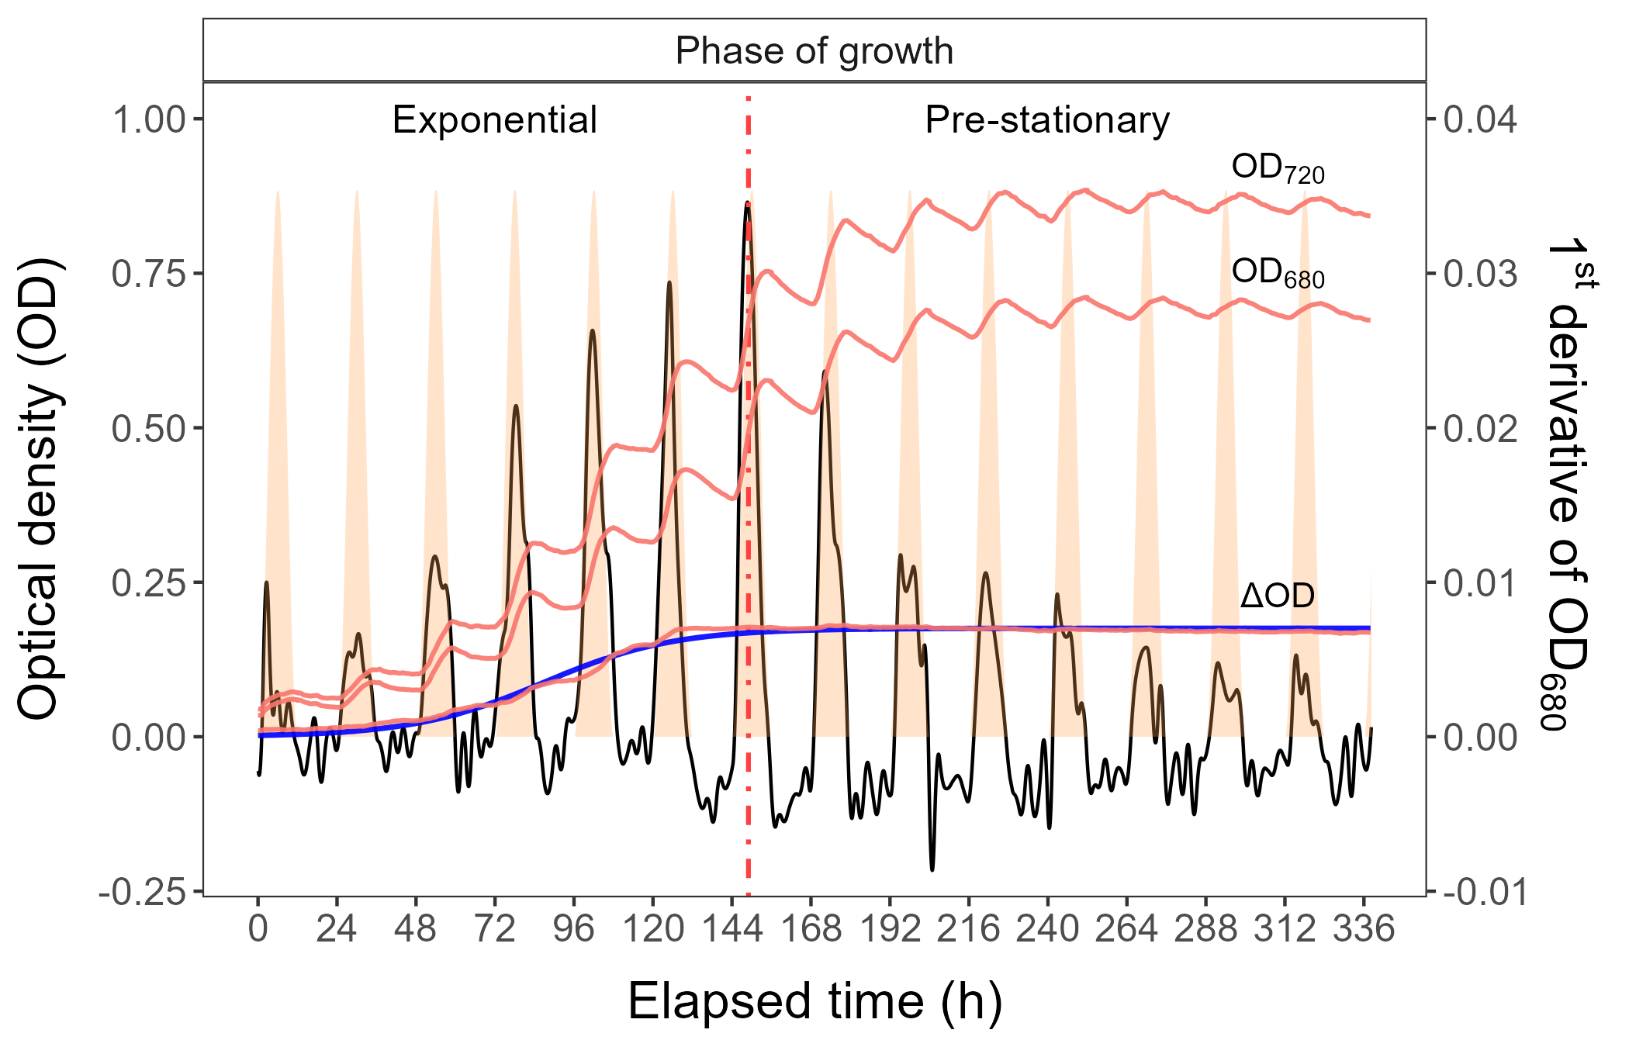

Figure 1: **Example of a growth curve (tracked as OD720, OD680, or ΔOD; red solid lines, left y-axis) of PE-rich culture of *Synechococcus* sp. (048) vs. elapsed time (h, x-axis).** 1st derivative of OD680 taken over 1 h increments (black solid line, right y-axis); solid blue line shows logistic fits of chlorophyll proxy OD680 – OD720 (ΔOD) vs. elapsed time. The vertical red dot dash line represents the time when the culture reached the maximum of the 1st derivative of OD680, or maximum absolute hourly growth (tMaxAHG), taken as an index of transition from exponential to pre-stationary growth phases.

## Determining the number of cells

The number of picocyanobacterial cells was calculated using linear regression models based on cell concentration (N mL−1) and OD at 680 nm. The OD of cultures was measured using a CLARIOstar Plus Plate Reader (BMG, Labtech, Ortenberg, Germany) and calculation of the cell number was conducted using the PAMAS S40 GO Particle counter (PAMAS Partikelmess- und Analysesysteme GmbH, Rutesheim, Germany). Linear correlations between N and OD680 for individual strains were used to estimate the number of cells based on OD measurements obtained from the Multi-Cultivator system. Linear regression, coefficient of determination, Pearson correlation coefficients, and *p*-value were presented in Tab. S1 (Supplementary materials).

## Whole-cell absorbance spectra measurements

Absorbance measurements on intact cells in suspension were conducted in OLIS CLARiTY 17 UV/Vis/NIR with integrating cavity upgrade spectrophotometer (On-Line Instrument Systems, Inc., Bogart, GA, USA) according to the method described by Blake and Griff [30] with modifications. In an experiment, identical 8 mL solutions that contained f/2 medium, were added to both the sample and reference observation cavities of the spectrophotometer. After recording a baseline from 375 to 710 nm, 1 mL was withdrawn from the sample cavity and replaced with 1 mL of the cell suspension of tested picocyanobacteria. The pathlength corrected absorbance per cm was performed by determining the Javorfi coefficients [31] as described in the equipment manual.

## Estimating Photosynthetically Usable Radiation (PUR)

Using whole-cell absorbance spectra of *Synechococcus* sp. cultures as described above (Fig. 2) we estimated Photosynthetically Usable Radiation (PUR) according to the method proposed by Morel [1]. Initially, we normalized the obtained whole-cell absorbances (A440nm) and emission spectra of the white LED lamps (Em440nm) to a reference wavelength of 440 nm. The PUR value, which is the ratio of the normalized sum of absorbance (A440nm) and normalized emission spectra (Em440nm) to the sum of the normalized emission spectra multiplied by the intensity of the tested light (PAR) was calculated (Eq. (1)).

$$PUR=\frac{∑\left(A_{440}⋅Em_{440}\right)}{∑\left(Em_{440}\right)}⋅PAR \left(1\right)$$



Figure 2: **Whole-cell absorbance spectra of PC-rich (solid green lines) or PE-rich (dashed red lines) cultures of *Synechococcus* sp.** Representative absorbance spectra, normalized to A440nm, were measured from the exponential or pre-stationary phases of growth, together with emission spectra of the white LED lamp used for culture growth (Photosynthetically Active Radiation (PAR), normalized to emission at 440 nm (Em440nm, light gray area), in this example PAR was 300 µmol photons m−2s−1. Estimated Photosynthetically Usable Radiation (PUR) is shown as a green area for the PC-rich strain and a red area for the PE-rich strain, with PUR given for each culture (µE = µmol photons m−2s−1). Peaks characteristic of known pigments are labeled; Chl *a*, chlorophyll *a*; PC, phycocyanin; PE, phycoerythrin; PUB, phycourobilin; Car, carotenoids.

## Pigment content analysis

The pigment content: chlorophyll *a* (Chl *a*), carotenoids (Car), phycoerythrin (PE), phycocyanin (PC), and allophycocyanin (APC) in *Synechococcus* sp. cultures over time was estimated with previously determined linear correlations between pigment content obtained by extraction technique and absorbance values of individual pigment peaks (nm) obtained from the whole-cell absorbance spectra. Linear regression, coefficient of determination, Pearson correlation coefficients, and *p*-value were presented in Tab. S2 (Supplementary materials). Total amount of phycobilin pigments (Total Phyco) for individual strains was obtained by adding the content of PE, PC, and APC.

Pigments extraction were performed using formula from Strickland and Parsons [32] for Ch *a* and Car concentrations. PE, PC, and APC were calculated based on Bennett and Bogorad [33]. The extracts contained photosynthetic pigments were measured using a CLARIOstar Plus Plate Reader (BMG, Labtech, Ortenberg, Germany), at wavelengths of 480, 665, and 750 nm for Chl *a* and Car calculation and at 565, 620, 650, and 750 nm for PE, PC, and APC. The values of individual pigment peaks (nm) from the whole-cell absorbance spectra were obtained by Olis-modernized Cary 14 UV/Vis/NIR with Integrating Sphere upgrade spectrophotometer (On-Line Instrument Systems, Inc., Bogart, GA, USA). For the linear model, the following wavelengths were analyzed: 480 (Car), 565 (PE), 620 (PC), 650 (APC), and 665 (Chl *a*) nm.

## Estimating cumulative diel PAR

Based on the length and shape of the photoperiod (sine wave for photoperiod of 8 – 16 h; square for photoperiod of 24 h) and the given light level, we estimated the value of the cumulative diel PAR. For a photoperiod arranged in the shape of a sine wave we used Eq. (2). For a continuous 24 h photoperiod we used Eq. (3).

$$\begin{matrix}Cumulative diel PAR \left(µmol photons m^{−2} d^{−1}\right)= \\ \frac{PAR \left(µmol photons m^{−2} s^{−1}\right)⋅60 \left(s min^{−1}\right)⋅60 \left(min h^{−1}\right)⋅photoperiod \left(h d^{−1}\right)}{2} \left(2\right)\end{matrix}$$

$$\begin{matrix}Cumulative diel PAR \left(µmol photons m^{−2} d^{−1}\right)= \\ PAR \left(µmol photons m^{−2} s^{−1}\right)⋅60 \left(s min^{−1}\right)⋅60 \left(min h^{−1}\right)⋅photoperiod \left(h d^{−1}\right) \left(3\right)\end{matrix}$$

## Changes effective absorption cross section of PSII and PSII flux

xxx I really need Doug help here!

Calculation of the absorption cross section of PSII photochemistry (PSII’; nm2 quanta−1) under ambient light through an iterative curve fit to the saturation phase of a Fast Repetition Rate fluorometry (FRRf) single turnover (ST) measurement of tested picocyanobacteria were obtained using SoliSense laser-induced fluorescence transient (LIFT) fluorometer equipped with a prototype temperature control unit (LIFT-REM, Soliense Inc., New York, USA). PSII flux (JVPSII; e−cell−1d−1) was calculated according to the method proposed by [Campbell?; Oxborough et al., 2012].

PC-rich and PE-rich picocyanobacteria were measured under diel peak PAR growth light under a blue LED (Ex445nm) and orange (Ex590nm) excitation. Excitation protocols were used to manipulate the level of photosynthetic activity and chlorophyll fluorescence (ChlF). Flash Power for blue excitation was 60000 and for orange excitation was 14000 µmol photons m−2s−1. The intensity of the blue and orange LIFT LED in DC mode and excitation power were calibrated using a quantum sensor (LI-250, LI-COR, Inc.). Data were collected during a rapid light curve (RLC) sequence during which light intensity was increased from 0 to 320 µmol photons m−2s−1 and then decreased from 320 to 0 µmol photons m−2s−1 with a 1-s pause in darkness between measurements. Acquisitions were made at 10-s intervals. [Campbell and Kolber?; Kolber et al., 2005; Oxborough et al., 2012].

Kolber, Z., Klimov, D., Ananyev, G., Rascher, U., Berry, J., & Osmond, B. (2005). Measuring photosynthetic parameters at a distance: laser induced fluorescence transient (LIFT) method for remote measurements of photosynthesis in terrestrial vegetation. Photosynthesis research, 84, 121-129.

Oxborough, K., Moore, C. M., Suggett, D. J., Lawson, T., Chan, H. G., & Geider, R. J. (2012). Direct estimation of functional PSII reaction center concentration and PSII electron flux on a volume basis: a new approach to the analysis of Fast Repetition Rate fluorometry (FRRf) data. Limnology and Oceanography: Methods, 10(3), 142-154.

Keller, B., Vass, I., Matsubara, S., Paul, K., Jedmowski, C., Pieruschka, R., … & Muller, O. (2019). Maximum fluorescence and electron transport kinetics determined by light-induced fluorescence transients (LIFT) for photosynthesis phenotyping. Photosynthesis Research, 140, 221-233.

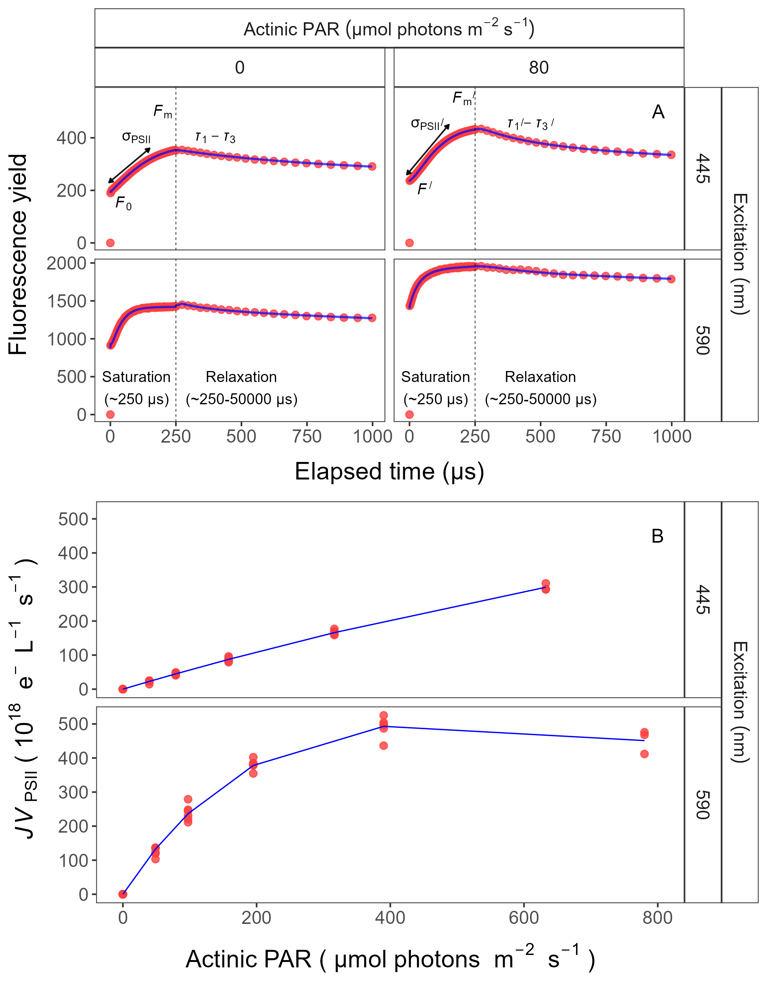

Figure 3: **Single turnover (ST) fluorescence induction techniques employed by the Fast Repetition Rate fluorometry (FRRf).** Examples of fluorescence yield vs. elapsed time (µs) are shown for PE-rich culture of *Synechococcus* sp. (048) in the dark (dark-adapted; 0) and under actinic PAR (in this example actinic PAR was 80 µmol photons m−2s−1) measured under blue LED (Ex445nm) or orange (Ex590nm) excitation (A). The ST technique delivers a series of flashlets. The LIFT/FRR instrument enables for non-intrusive, continuous monitoring of chlorophyll fluorescence parameters (including *F*0, *F*’, *F*m, *F*m‘, τ1-τ3, τ1’-τ3‘, σPSII, and σPSII’). Bottom panel showed single rapid light curve (RLC), estimated with with a three parameter model [34], for PSII flux (*JV*PSII; e−L−1s−1) vs. actinic PAR measured under blue LED (Ex445nm) or orange (Ex590nm) excitation (B).

## Statistical analysis

All analysis of obtained results was conducted using R version 4.3.0 [35] running under RStudio [36]. To determine significant differences in studied experiments the “stats” v. 3.6.2 R standard packages were used. This package provides basic statistical functions, including the *lm()* function for linear regression, *aov()* function for ANOVA, and *t.test()* function for t-test. The *SSasymp()* function (Self-Starting Nls Asymptotic Regression Model) was used to perform a single phase exponential decay fit model and to estimate exponential decay parameters (y0, the starting value; yf, the value at infinite times; $λ$, exponential decay constant) [37]. A modified Levenberg-Marquardt fitting algorithm [29] was used for estimating logistic fits of chlorophyll proxy OD680 – OD720 vs. elapsed time for each combination of strain, photoperiod, and peak PAR. We also used *nlsLM()* function [29] to perform a three parameter model ($α$, initial slope of curve; $β$, reflecting the photoinhibition process; Pmax, the maximum rate of growth curve) proposed by Harrison and Platt [34].

Linear regressions were used to calculate the number of cells (N mL−1) and pigment content (µg mL−1) for two PhycoCyanin(PC)-rich cultures (056, 077) and two PhycoErythrin(PE)-rich cultures (048, 127) of *Synechococcus* sp. originating from the Baltic Sea. Linear regression, coefficient of determination (R square), Pearson correlation coefficients (R), and *p*-value were presented in Table S1-S2 (in Supplemental material).

We performed three-way factorial ANOVA of chlorophyll specific exponential growth rate, estimated from logistic fits of chlorophyll proxy OD680 – OD720, PUR/PAR ratio, total Phyco/Chl *a* ratio, and effective absorption cross section of PSII (PSII’; nm2 quanta−1) measured under diel peak PAR growth light under Ex445nm (blue) or under Ex590nm (orange) excitation in relation to the cumulative diel photon dose (µmol photons m−2d−1) or in relation to the total Phyco/Chl *a* ratio (Table S3, S6, S8, S10, S12, S14, S16 in Supplemental material).

To examine statistical differences between models, we performed one-way ANOVA of a three parameter model [34] from pooled data and data fit across different photoperiods (8, 12, 16, or 24) or data fit across different peak PAR (30, 90, 180, 300, 600 together with 900) from chlorophyll specific exponential growth rate, for two PhycoCyanin(PC)-rich cultures (056, 077) and two PhycoErythrin(PE)-rich cultures (048, 127) of *Synechococcus* sp. originating from the Baltic Sea, grown at 30, 90, 180, 300, 600, or 900 peak PAR µmol photons m−2s−1; and photoperiods of 8, 12, 16, or 24 h (Table S4-S5 in Supplemental material). One-way ANOVA was also used to examine statistical differences between single phase exponential decay fit model of pooled data across different strains for a given phase of growth and across different phase of growth for a given strain from PUR/PAR ratio, total Phyco/Chl *a* ratio, and effective absorption cross section of PSII (PSII’; nm2 quanta−1) measured under diel peak PAR growth light under Ex590nm (orange) excitation in relation to the cumulative diel photon dose (µmol photons m−2d−1) (Table S7, S9, S13 in Supplemental material).

T-test of linear fit model of pooled data across different strains for a given phase of growth and across different phase of growth for a given strain from effective absorption cross section of PSII (PSII‘; nm2 quanta−1) measured under diel peak PAR growth light under Ex445nm (blue) excitation in relation to the cumulative diel photon dose (µmol photons m−2d−1) or in relation to the total Phyco/Chl *a* ratio, as well as from effective absorption cross section of PSII (PSII’ or PSII; nm2 quanta−1) measured under Ex590nm (orange) excitation in relation to the total Phyco/Chl *a* ratio was performed (Table S11, S15, S17 in Supplemental material).

Statistical differences for all analyzes were determined at the level of significance $α$ = 0.05. Manuscript was prepared as a Rmarkdown document [38]. Figures were plotted using “ggplot” [39] R package.

# Results

## Changes in chlorophyll specific exponential growth rate

In this study, the chlorophyll specific exponential growth rates (μ; d−1) vs. cumulative diel photon dose (µmol photons m−2d−1) for two PhycoCyanin(PC)-rich cultures (056, 077) and two PhycoErythrin(PE)-rich cultures (048, 127) of *Synechococcus* sp. originating from the Baltic Sea were determined. Growth rates were estimated from logistic fits of chlorophyll proxy OD680 - OD720 vs. elapsed time for picocyanobacteria cultures grown at 30, 90, 180, 300, 600 or 900 peak PAR µmol photons m−2s−1 (µE); and photoperiods of 8, 12, 16, or 24 h (Fig. ??).

Analyzed phenotypes of *Synechococcus* sp. showed varying chlorophyll specific exponential growth rates (μ) under different photoperiod and light conditions. Three-way factorial ANOVA showed that individual factor (irradiance, photoperiod, and strain) and their interactions significantly affected the μ, estimated from logistic fits of chlorophyll proxy OD680 - OD720 vs. elapsed time (ANOVA, *p* < 0.05 for all; Table S3). All tested strains were able to grow even under peak PAR 900 µmol photons m−2s−1 and 24 h photoperiod, except PE-rich_048. The highest growth rate was recorded for *Synechococcus* sp. PE-rich_127 (μ = 4.5 d−1) and PC-rich_056 (μ = 3.4 d−1) at the 180 µmol photons m−2s−1 and photoperiod of 24 h.

We also found that cumulative diel photon dose consistently explains achieved μ across a matrix of photoperiods and peak PAR. Every strain showed distinct growth responses to cumulative diel photon dose, depending upon photoperiod. One-way ANOVA of a three parameter model [34] from μ for two PC-rich and two PE-rich cultures of *Synechococcus* sp. showed significant difference between model performed from pooled data and data fit across all tested photoperiods (8, 12, 16, or 24 h; ANOVA, *p* < 0.05, Table S4 in Supplemental material). Strains also showed distinct growth responses to cumulative diel photon dose, depending upon peak PAR. In supplemental data (Fig. S5), strains generally showed peak-PAR specific responses to cumulative diel photon dose, that differ from a single light response model fit to the pooled data from a strain. Exceptions were observed in the strains PC-rich_077 and PE-rich_048 with the peak PAR of 600 or 900 µmol photons m−2s−1, which were not significantly different from the pooled data model (Table S5 in Supplemental material). A caveat to these findings is that cumulative diel photon dose is a product of photoperiod and PAR, so the highest levels of cumulative photon dose are only achieved under the 600 or 900 µmol photons m−2s−1.

Growth rate saturated under increasing cumulative diel PAR for all strains however, the achieved estimates of µmax varied depending upon photoperiod and peak diel PAR. Growth rates vs. cumulative diel PUR relationships, estimated for exponential phase cultures, followed similar patterns (Fig. S6 and Table Sxxx in Supplemental material).

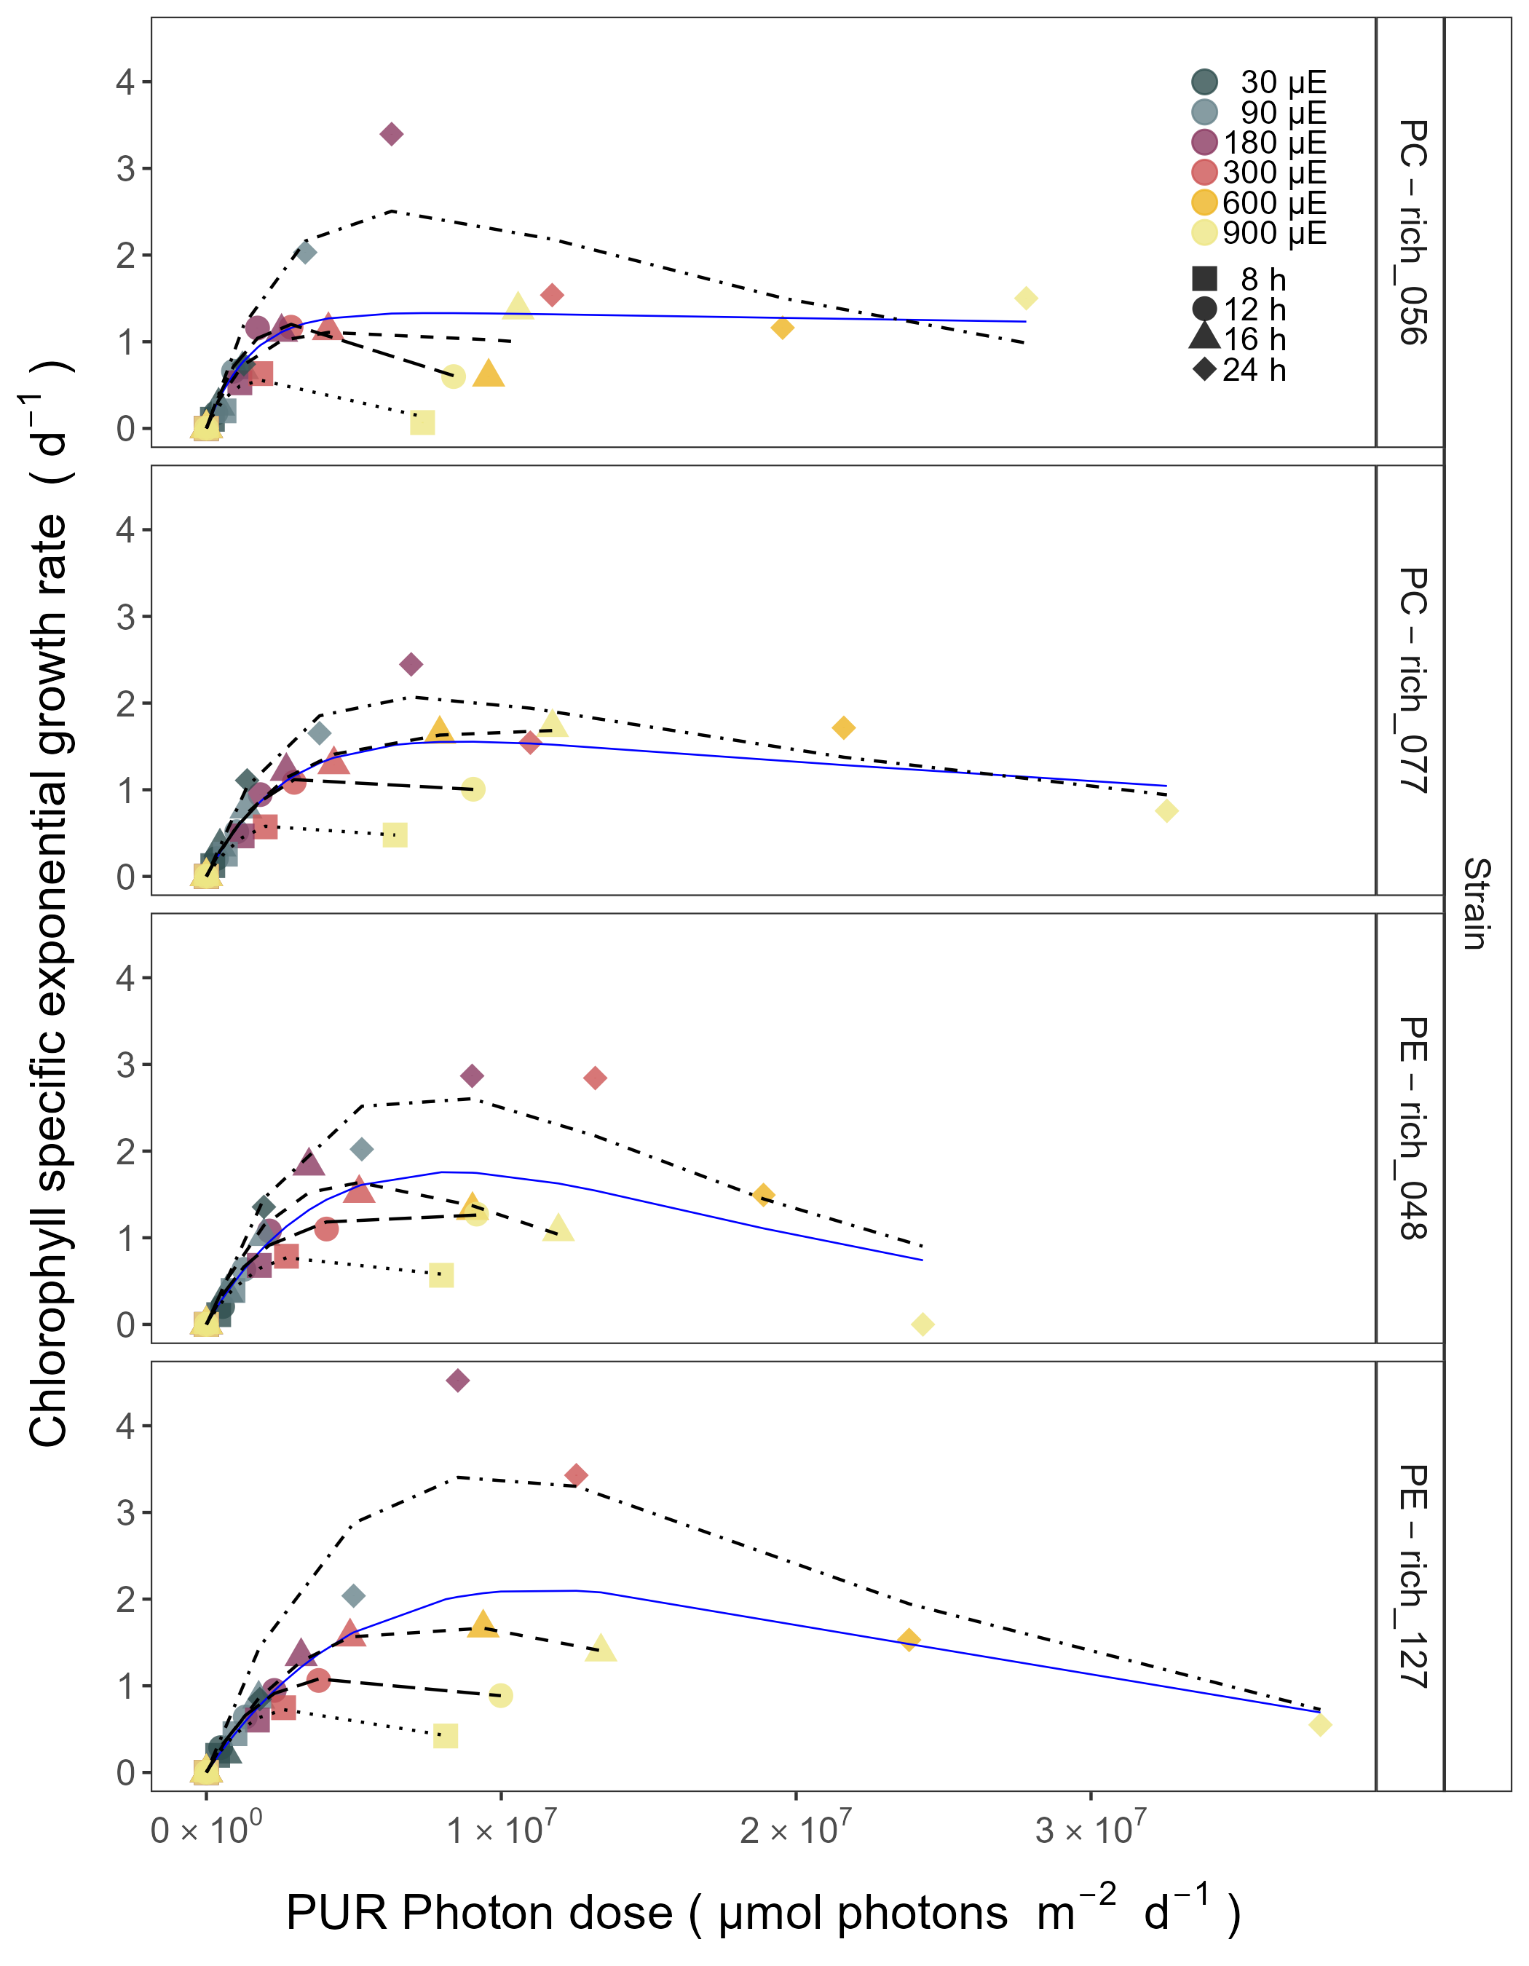

Figure 4: **Chlorophyll specific exponential growth rates (d−1) vs. cumulative diel Photosynthetically Usable Radiation (PUR, µmol photons m−2d−1).** Growth rates (+/- SE falling within symbols) were estimated from logistic fits of chlorophyll proxy OD680 - OD720 vs. elapsed time (Fig. 1, S4), for two PhycoCyanin(PC)-rich cultures (056, 077) and two PhycoErythrin(PE)-rich cultures (048, 127) of *Synechococcus* sp. originating from the Baltic Sea. Cultures were grown at 30 (dark gray), 90 (light gray), 180 (purple), 300 (red), 600 (orange), or 900 (yellow) peak PAR µmol photons m−2s−1 (µE); and photoperiods of 8 (square), 12 (circle), 16 (triangle), or 24 (diamond) h. Solid blue line shows a fit of the pooled growth rates for each strain, with a three parameter model [34]. We also fit the same model separately for 8 (dotted line), 12 (long dash line), 16 (dashed line), or 24 (two dash line) h photoperiods, since for all strains they were each significantly different (ANOVA, *p* < 0.05) from the fit of pooled data.

## Decreasing PUR/PAR ratio with increasing cumulative photon dose

Changes of PUR/PAR ratio vs. cumulative diel photon dose (µmol photons m−2d−1) for two PC-rich cultures (056, 077) and two PE-rich (048, 127) cultures of *Synechococcus* sp. grown at 30, 90, 180, 300, 600, or 900 peak PAR µmol photons m−2s−1 (µE); and photoperiods of 8, 12, 16, or 24 h were estimated (Fig. 5). Three-way factorial ANOVA showed that individual factor (cumulative diel photon dose, phase of growth, or strain) but not the interactions of these 3 factors, affected the PUR/PAR ratio (ANOVA, *p* < 0.05, Table S6).

Strains also showed consistent patterns of light capture efficacy (PUR/PAR ratio) across cumulative diel photon doses. The ratio of PUR/PAR decayed exponentially in relation to cumulative photon dose, across different combinations of photoperiod and peak PAR. Although all strains followed a similar trend, the single phase exponential decay fit models varied significantly among strains during their exponential phase of growth (ANOVA, *p* < 0.05, Table S7). The exception was the fit of the models PE-rich_048 and PE-rich_127 (ANOVA, *p* > 0.05). During pre-stationary phase this response dampens and even disappears (ANOVA, *p* > 0.05, Table S7). Significant differences between the fit models for different phases of growth within all given strains with the exception of PC-rich_056 were also noted (ANOVA; *p* < 0.05, Table S7). Moreover, the PUR/PAR ratio was significantly higher in the PE-rich strains under low cumulative diel photon dose during their exponential phase of growth; however, decay towards a plateau close to the PC-rich strains as cumulative diel photon dose increases.

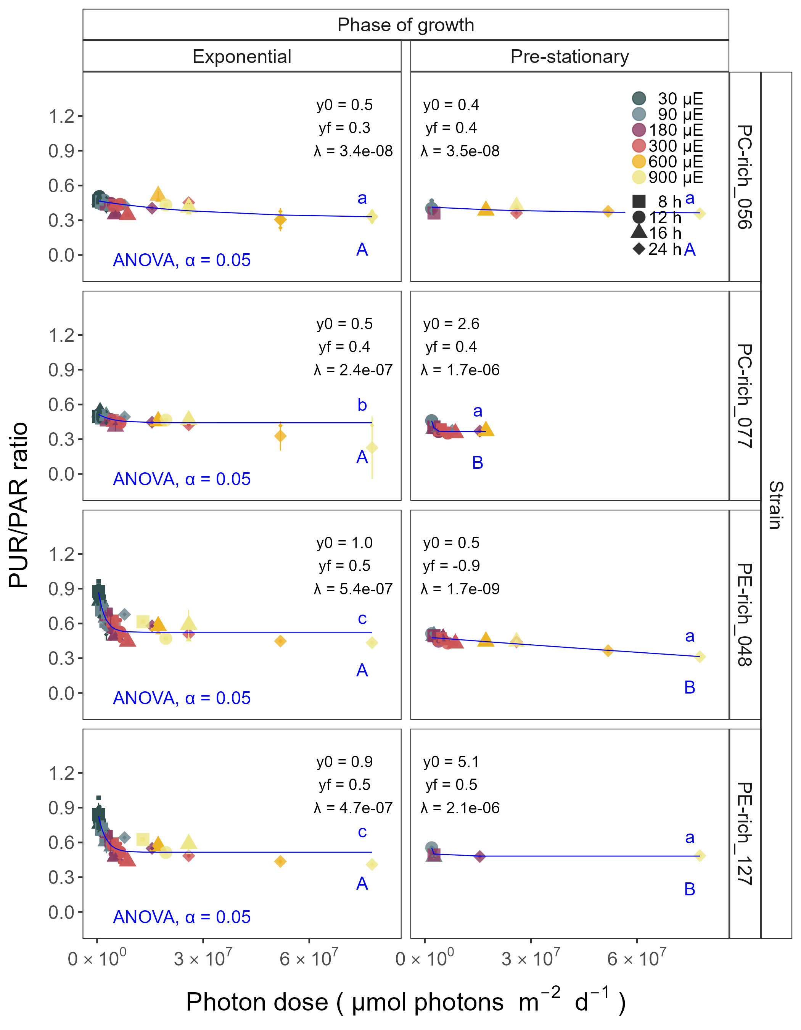

Figure 5: **Changes of PUR/PAR ratio vs. cumulative diel PAR photon dose (µmol photons m−2d−1).** PUR/PAR ratio was estimated for two PhycoCyanin(PC)-rich cultures (056, 077) and two PhycoErythrin(PE)-rich cultures (048, 127) of *Synechococcus* sp. originating from the Baltic Sea. Cultures were grown at 30 (dark gray), 90 (light gray), 180 (purple), 300 (red), 600 (orange), or 900 (yellow) peak PAR µmol photons m−2s−1 (µE); and photoperiods of 8 (square), 12 (circle), 16 (triangle), or 24 (diamond) h. Figure presents data (small symbols) and means (big symbols) from exponential phase of growth, or from pre-stationary phase of growth. Blue solid line shows single phase exponential decay fit for data from each strain and growth phase, with fit parameters presented. Different lowercase letters indicate statistically significant differences between the fit models for different strains within a given phase of growth. Different uppercase letters indicate statistically significant differences between the fit models for different phases of growth within a given strain (ANOVA; *p* < 0.05).

## Decreasing effective absorption cross section of PSII with increasing cumulative photon dose

In this work, we estimated the effective absorption cross section of PSII (PSII‘; nm2 quanta−1) measured under diel peak PAR growth light vs. cumulative diel photon dose (µmol photons m−2d−1). PSII’ was estimated using FRRf induction curves using Ex590nm (orange) excitation, for two PC-rich (056, 077) and two PE-rich (048, 127) cultures of *Synechococcus* sp. grown at 30, 90, 180, 300, 600, or 900 peak PAR µmol photons m−2s−1 (µE); and photoperiods of 8, 12, 16, or 24 h (Fig. 6). The PSII’ measured under diel peak PAR growth light under Ex445nm (blue) excitation vs. cumulative diel photon dose was shown in Supplementary material (Fig. S10, Table S10-S11).

Similarly to the PUR/PAR ratio, three-way factorial ANOVA showed that individual factor (cumulative diel photon dose, phase of growth, or strain) and their interactions, significantly affected the PSII’ measured under diel peak PAR growth light under Ex590nm excitation (ANOVA, *p* < 0.05; Table S12 in Supplemental material).

All strains showed consistent patterns of effective absorption cross section for PSII photochemistry across cumulative diel photon doses. The PSII’ examined a consistent, sharp exponential decay in relation to cumulative photon dose, across different combinations of photoperiod and peak PAR. Although all strains showed this response pattern, the exponential decay fit models differ significantly among two PC-rich strains and PE-rich_048 during their exponential phase of growth (ANOVA, *p* < 0.05; Table S13 in Supplemental material). During pre-stationary phase this response dampens but persists. Additionally, the significant differences between the fit models for different phases of growth within all given strains, with the exception of PE-rich_048, were also presented (ANOVA; *p* < 0.05, Table S13).

The PE-rich strains showed higher PSII’ under low cumulative diel photon dose, and remain higher than the PC-rich strains even as cumulative diel photon dose increases.

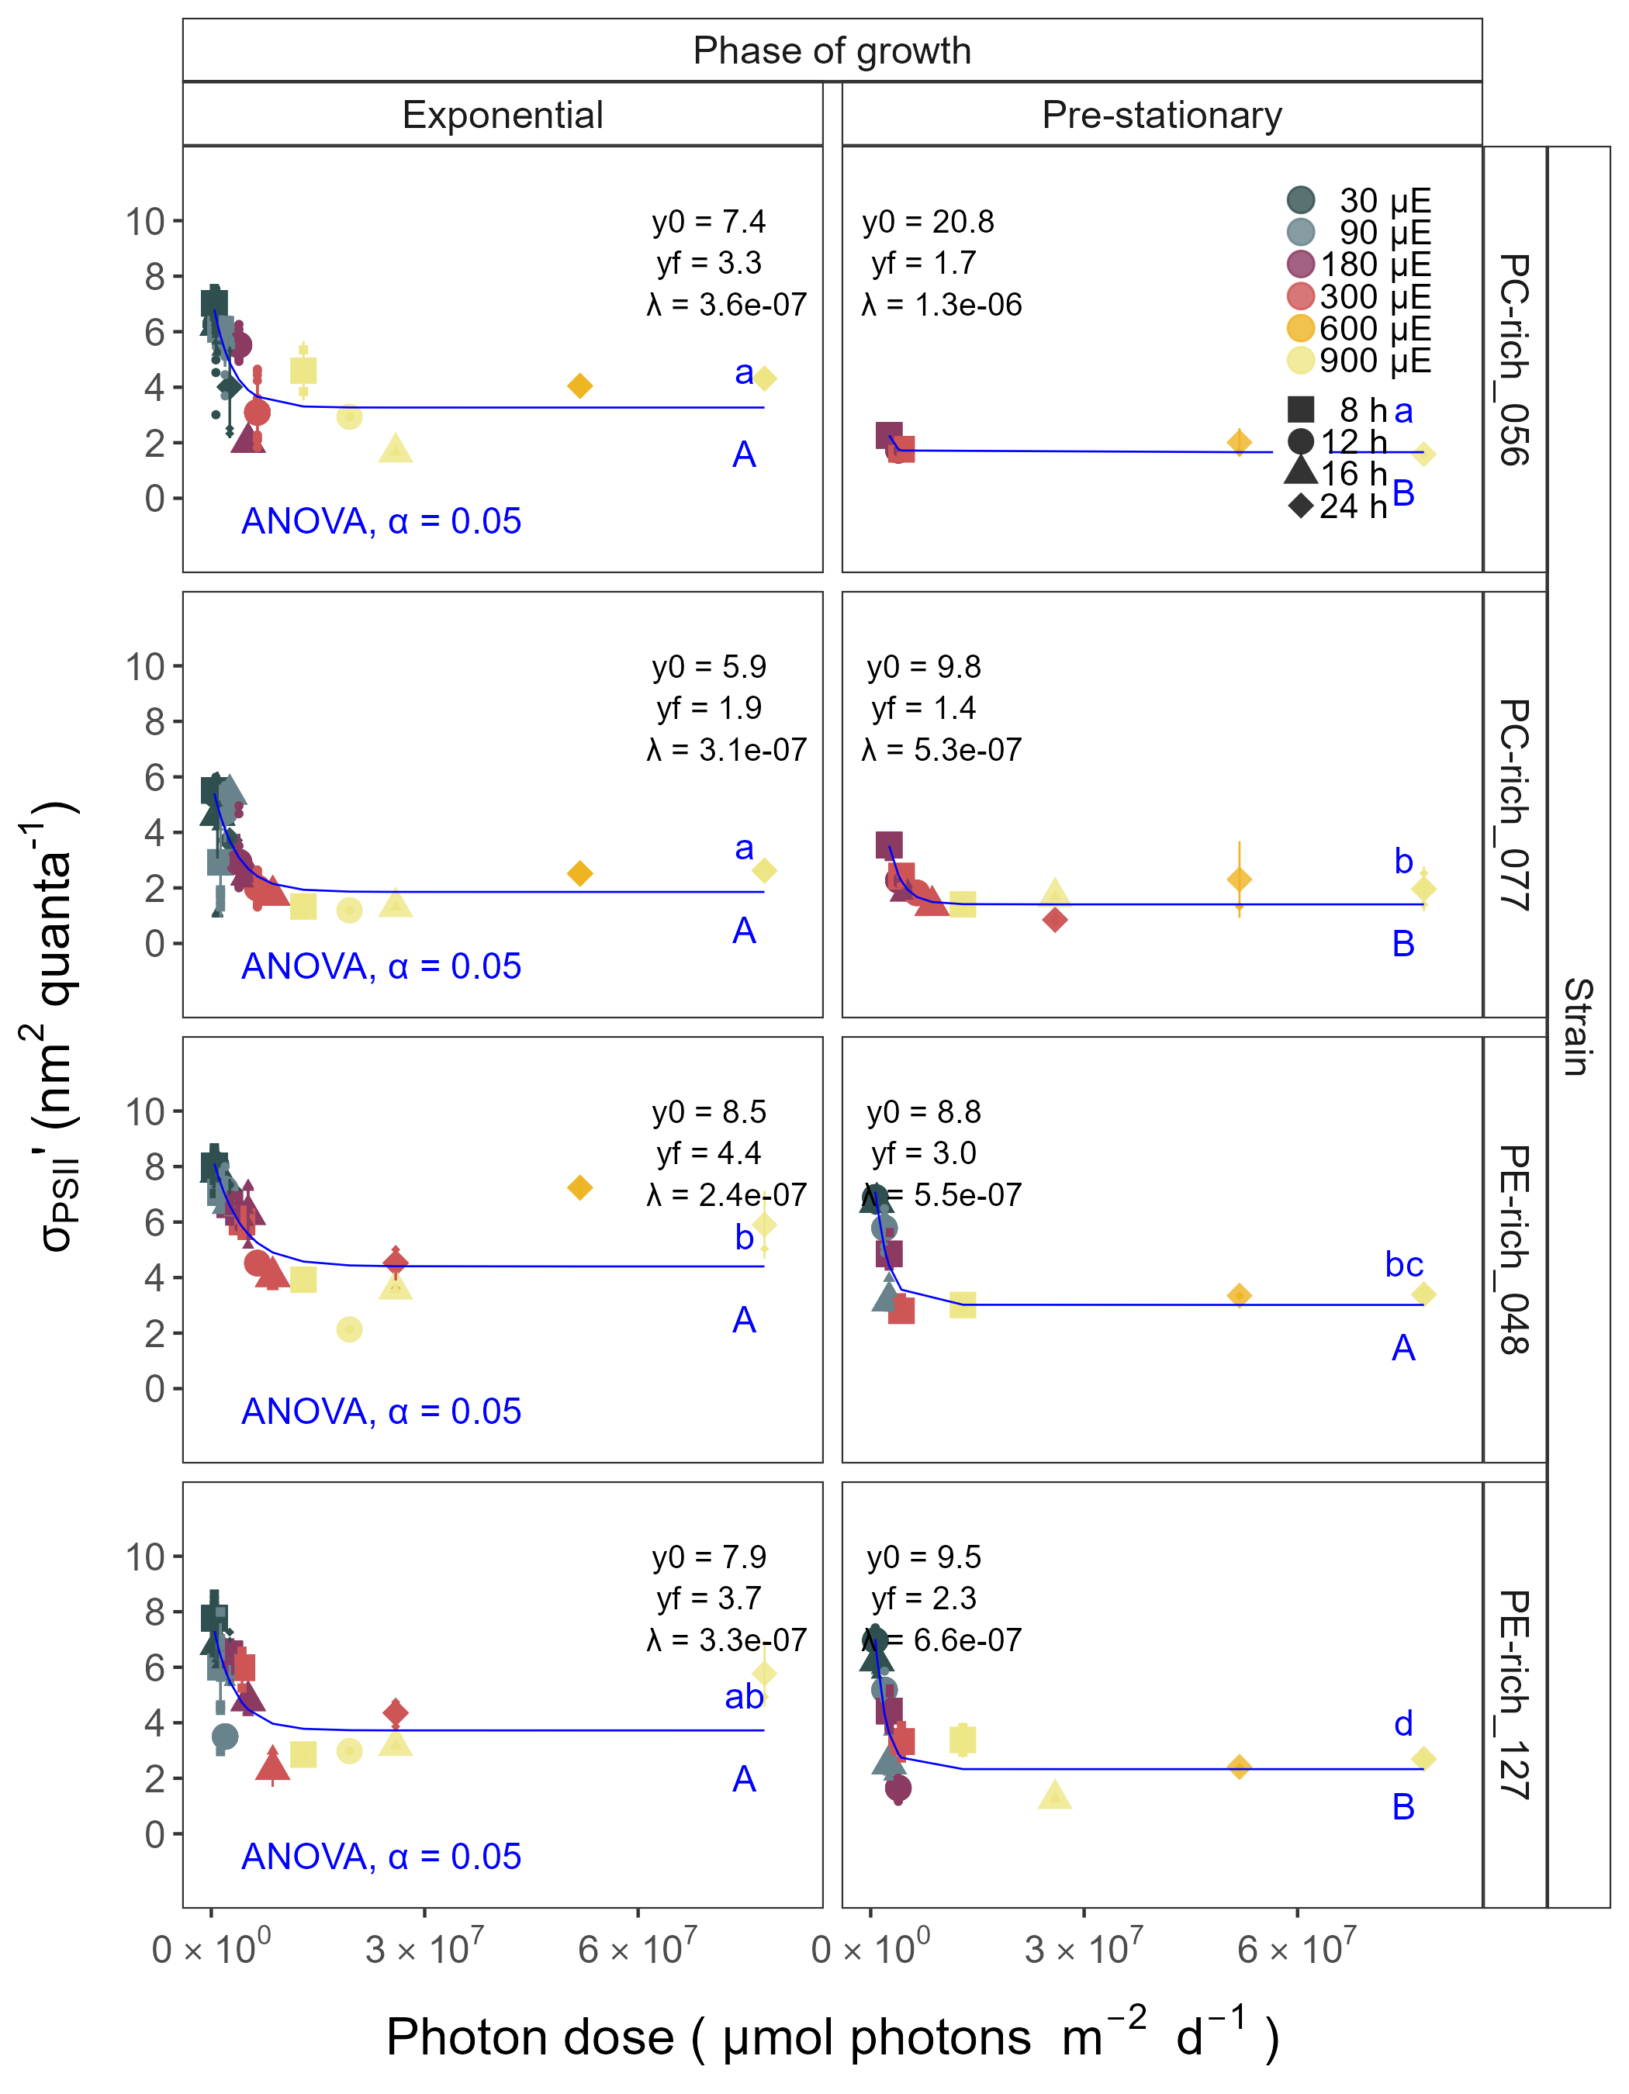

Figure 6: **Effective absorption cross section of PSII** (σPSII‘; nm2 quanta−1) **measured under diel peak PAR growth light vs. cumulative diel PAR photon dose (µmol photons m−2d−1).** Effective absorption cross section of PSII (σPSII’; nm2 quanta−1) was estimated using FRRf induction curves with excitation of phycobilisomes (Ex590nm, orange), for two PhycoCyanin(PC)-rich cultures (056, 077) and two PhycoErythrin(PE)-rich cultures (048, 127) of *Synechococcus* sp. originating from the Baltic Sea. Cultures were grown at 30 (dark gray), 90 (light gray), 180 (purple), 300 (red), 600 (orange), or 900 (yellow) peak PAR µmol photons m−2s−1 (µE); and photoperiods of 8 (square), 12 (circle), 16 (triangle), or 24 (diamond) h. Figure presents data (small symbols) and means (big symbols) from exponential phase of growth, or from pre-stationary phase of growth. Blue solid line shows single phase exponential decay fit for data from each strain and growth phase. Different lowercase letters indicate statistically significant differences between the fit models for different strains within a given phase of growth. Different uppercase letters indicate statistically significant differences between the fit models for different phases of growth within a given strain (ANOVA; *p* < 0.05).

Changes of effective absorption cross section of PSII (PSII‘; nm2 quanta−1) measured under diel peak PAR growth light under Ex590nm (orange) excitation vs. total Phyco/Chl *a* ratio, for PC-rich_056, PC-rich_077, PE-rich_048, and PE-rich_127 cultures of *Synechococcus* sp. grown at 30, 90, 180, 300, 600, or 900 peak PAR µmol photons m−2s−1 (µE); and photoperiods of 8, 12, 16, or 24 h were demonstrated (Fig. 7). Changes of effective absorption cross section of PSII (PSII; nm2 quanta−1) measured at the dark period under Ex590nm (orange) excitation vs. total Phyco/Chl *a* ratio were shown in Supplementary material (Fig. S9, Table Sxxx). Also, the PSII’ measured under diel peak PAR growth light under Ex445nm (blue) excitation vs. total Phyco/Chl *a* ratio was shown in Fig. S11 and Table S14-S15.

In this work we found that PSII’ showed a consistent relation to phycobilisome:chlorophyll ratio. Three-way factorial ANOVA showed that individual factor (cumulative diel photon dose, phase of growth, or strain) and their interactions, significantly affected the PSII’ measured under diel peak PAR growth light under Ex590nm excitation relation to the total Phyco/Chl *a* ratio (ANOVA, *p* < 0.05; Table S16 in Supplemental material).

The PSII’ excited through chlorophyll absorbance at Ex445nm was consistently small across strains and growth conditions, since in cyanobacteria the number of chlorophyll serving PSII is nearly fixed (CITATIONS DOUG, Fig. S11). For PSII’ excited through phycobilisome absorbance at Ex590nm, strains show consistent positive correlation with total Phyco/Chl *a* ratio. Strains in exponential growth show significant scatter around this positive relation, likely related to regulatory control of PSII‘, beyond pigment composition. Under pre-stationary phase the relationship between PSII’ and total Phyco/Chl *a* ratio was more consistent, suggesting an increase in reliance upon compositional regulation to control light delivery to PSII, as opposed to shorter-term regulation.

The linear fits also vary significantly among strains. The linear fit models differ significantly among PC-rich_077 and two PE-rich strains during their exponential phase of growth. During pre-stationary phase we noted significant differences between two PC-rich strains and PE-rich_048. Moreover, the significant differences between the fit models for different phases of growth were noted for PC-rich strains 056 and 077 (t-test; *p* < 0.05, Table S17).

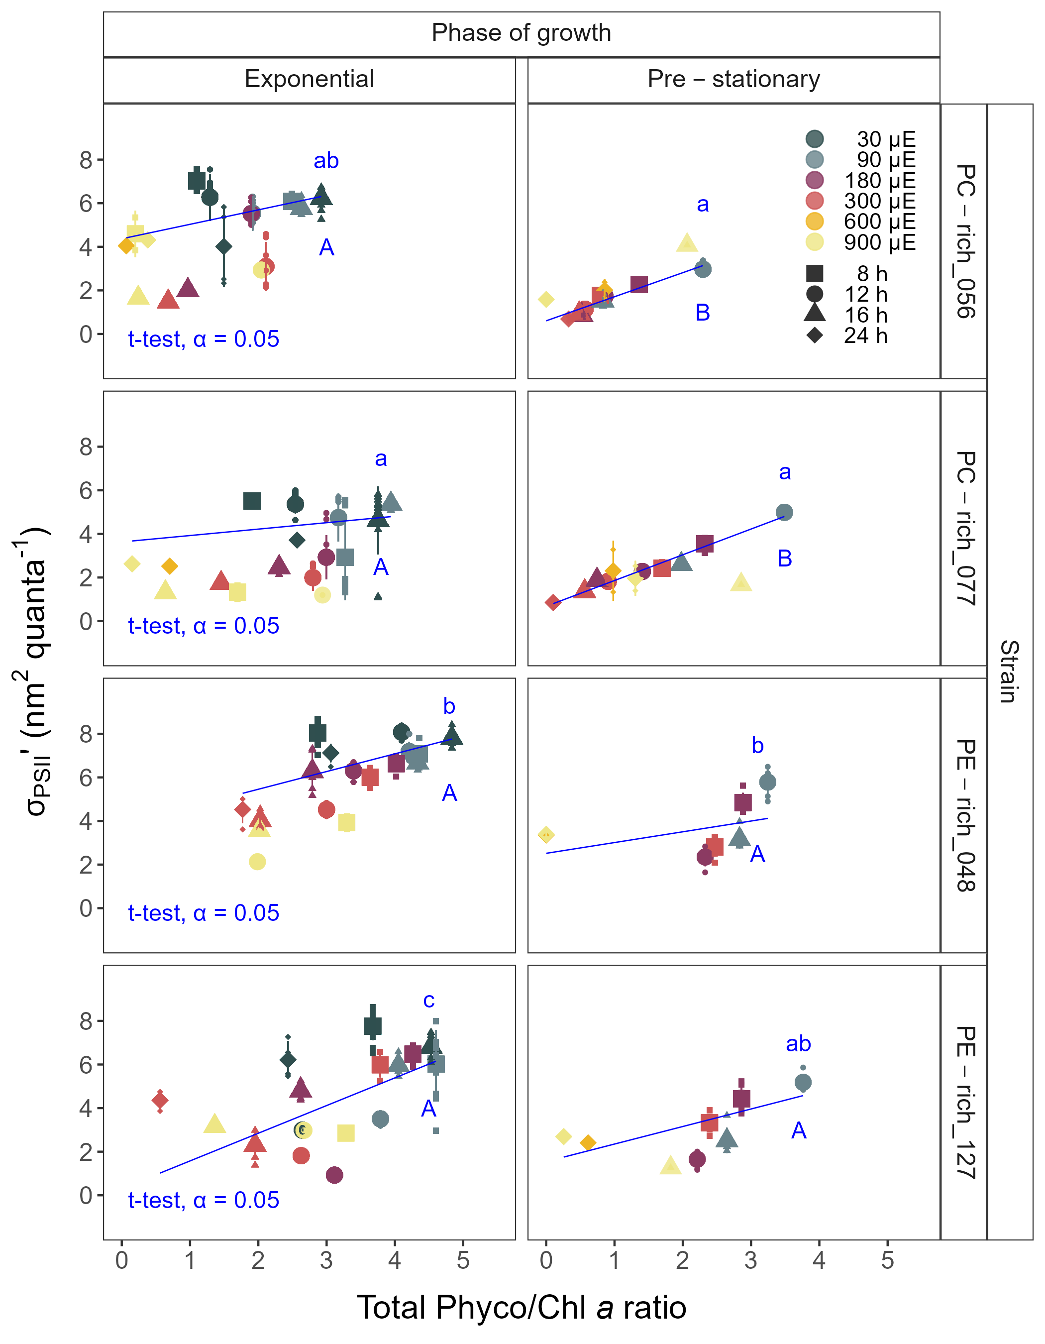

Figure 7: **Changes of effective absorption cross section of PSII** (σPSII’; nm2 quanta−1) **measured under diel peak PAR growth light with excitation of phycobilisomes (Ex590nm, orange) vs. the ratio of sum of µg phycobilins (PE, PC, APC protein, total Phyco)/µg Chl *a*;** for two PhycoCyanin(PC)-rich cultures (056, 077) and two PhycoErythrin(PE)-rich cultures (048, 127) of *Synechococcus* sp. originating from the Baltic Sea. Cultures were grown at 30 (dark gray), 90 (light gray), 180 (purple), 300 (red), 600 (orange), or 900 (yellow) peak PAR µmol photons m−2s−1 (µE); and photoperiods of 8 (square), 12 (circle), 16 (triangle), or 24 (diamond) h. Figure presents data (small symbols) and means (big symbols) from exponential phase of growth, or from pre-stationary phase of growth. Blue solid line shows linear model fit for data from each strain and growth phase. Different lowercase letters indicate statistically significant differences between the fit models for different strains within a given phase of growth. Different uppercase letters indicate statistically significant differences between the fit models for different phases of growth within a given strain (t-test; *p* < 0.05).

## Changes in PSII flux

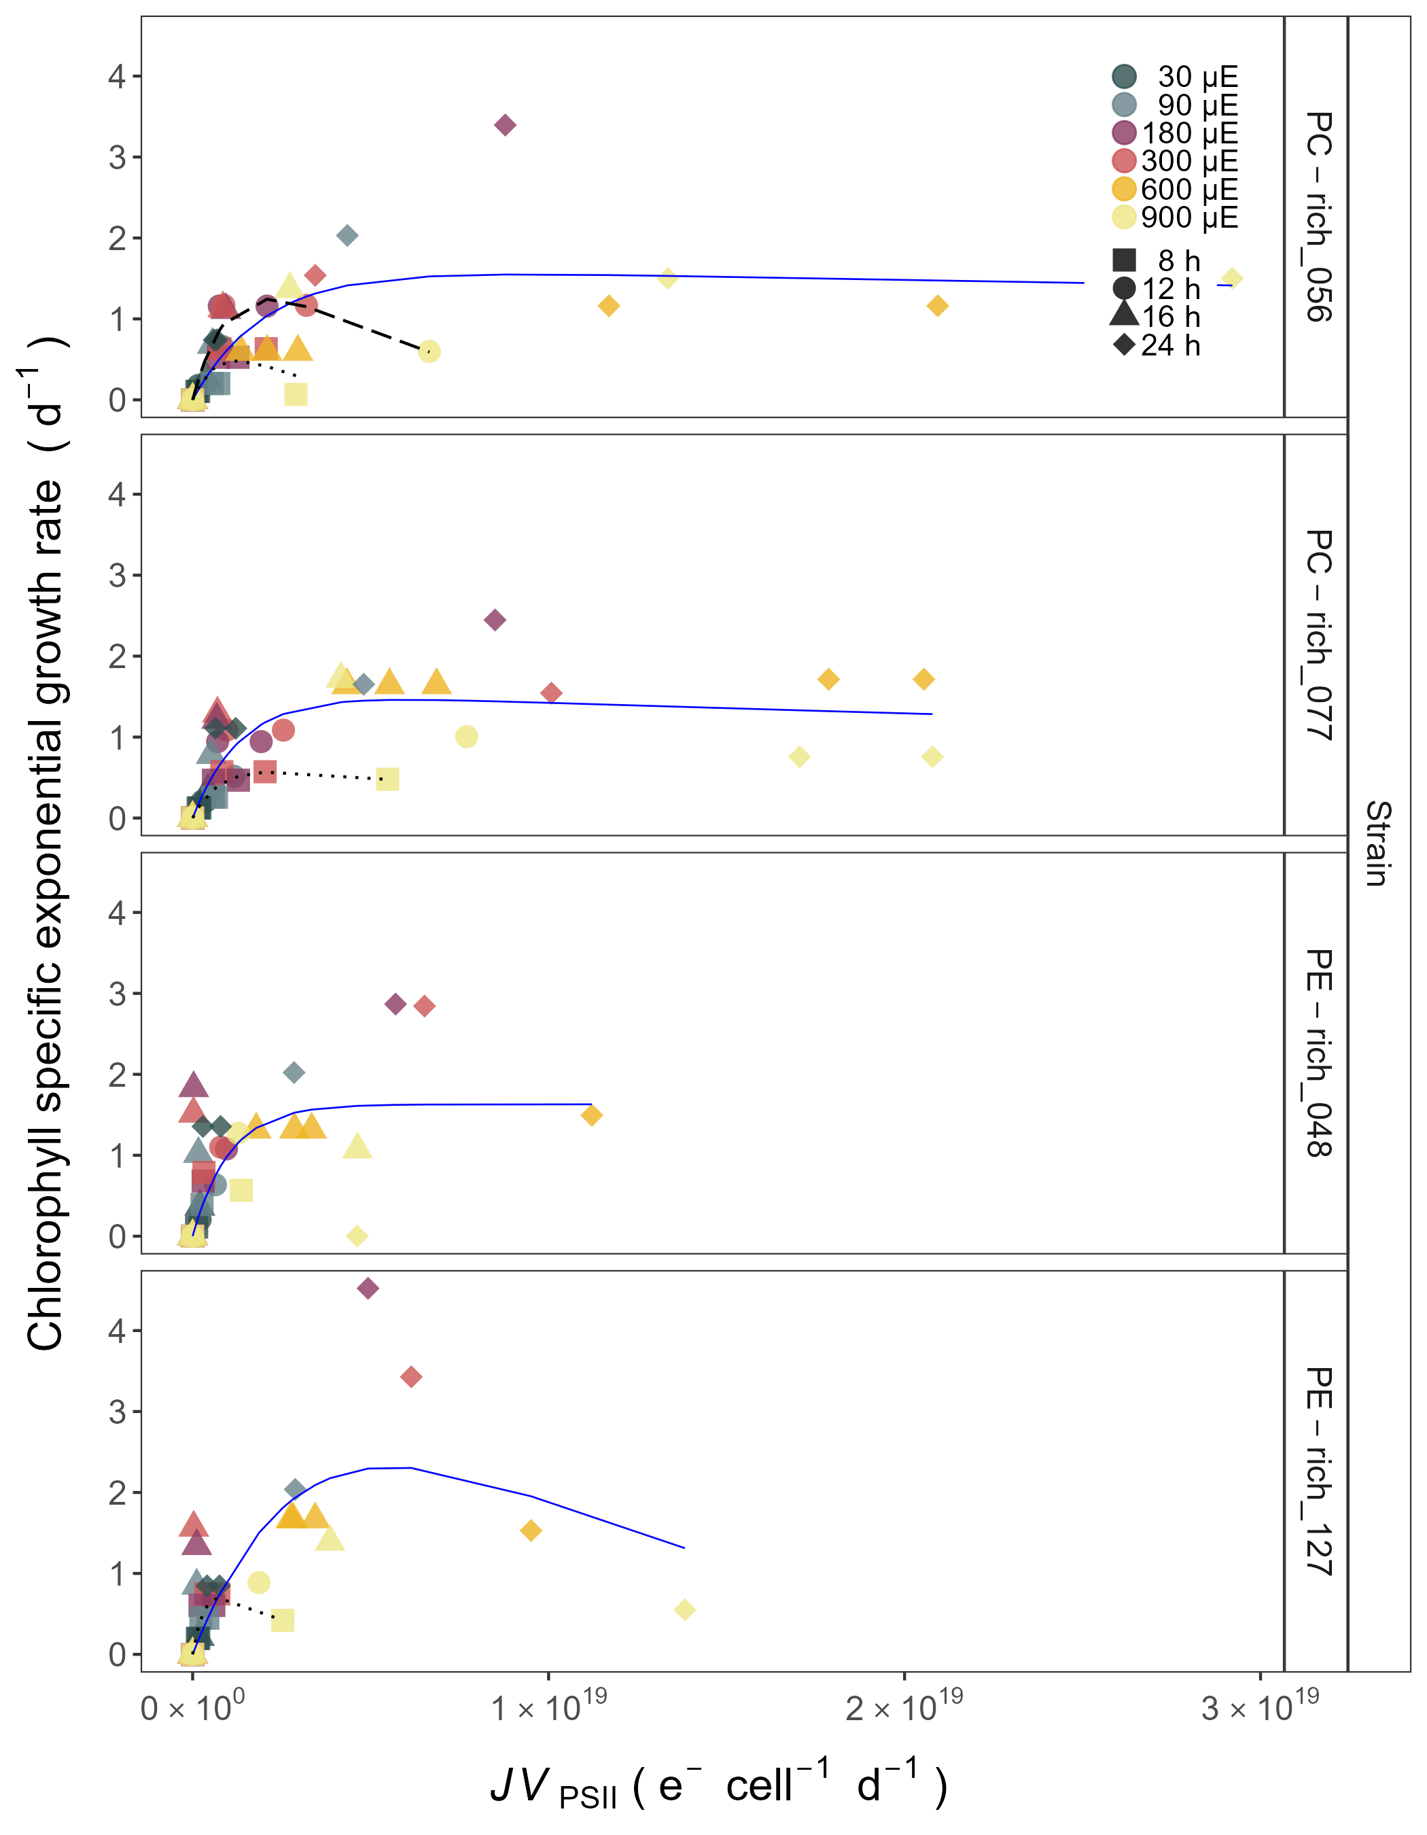

Figure 8: **Chlorophyll specific exponential growth rates (d−1) vs. PSII flux (*JV*PSII; e−cell−1d−1) measured under diel peak PAR growth light.** Growth rates (+/- SE falling within symbols) were estimated from logistic fits of chlorophyll proxy OD680 - OD720 vs. elapsed time (Fig. S4). PSII flux (*JV*PSII; e−cell−1d−1) was estimated using FRRf induction curves with excitation of chlorophyll (Ex445nm, blue), for two PhycoCyanin(PC)-rich cultures (056, 077) and two PhycoErythrin(PE)-rich cultures (048, 127) of *Synechococcus* sp. originating from the Baltic Sea. Cultures were grown at 30 (dark gray), 90 (light gray), 180 (purple), 300 (red), 600 (orange), or 900 (yellow) peak PAR µmol photons m−2s−1 (µE); and photoperiods of 8 (square), 12 (circle), 16 (triangle), or 24 (diamond) h. Solid blue line shows a fit of the pooled growth rates for each strain, with a three parameter model [34]. We also fit the same model separately for 8 (dotted line), 12 (long dash line), 16 (dashed line), or 24 (two dash line) h photoperiods, only when they were significantly different (ANOVA, *p* < 0.05) from the fit of pooled data.

# Discussion

## Photic regime significance for picocyanobacteria growth

### Photoperiod length

Changes in photoperiod trigger adaptive responses, shaping the temporal dynamics and community structure of phytoplankton [8–10]. This work revealed that not only the daily dose of light, but also the length of exposure affected the picocyanobacteria growth rate. The PE-rich and PC-rich strains of *Synechococcus* sp. showed faster chlorophyll specific exponential growth rates with increasing photoperiod, including constant light conditions. This is particularly important in regions with a longer photoperiod but relatively low irradiances, for example, in the Arctic and Antarctic regions, where PC-strains may become dominant species in the surface waters.

xxx - paper about existence pico in arctic. Maybe different regions?

Here, we confirmed that *Synechococcus* sp. can exist and even become the dominant faction of phytoplankton in all geographic zones on Earth as long as they have access to light. In regions with a longer photoperiod (summer in the temperate zone and summer at the poles), PC-strains may become dominant species in the surface waters whereas some of PC-strains of *Synechococcus* sp. may be less numerous than PE-strains in surface waters (where the light intensity could be extremely high) when the photoperiod is quite low (autumn and winter in temperate zones and tropical water throughout the year). Our research has also highlighted the possibility of occurrence of both PE-rich and PC-rich Synechococcus sp. in conditions of continuous irradiation. Thus, it can be predicted that *Synechococcus* may become the dominant fraction of phytoplankton during the Arctic summer near the poles regions regardless of their genetic lineages and pigments composition.

### Photosynthetically Active Radiation (PAR)

Numerous studies have highlighted the significance of PAR and light intensity as a key driver of phytoplankton productivity and its influence on ecosystem dynamics, biogeochemical cycling, and food web interactions [e.g., 5,6,7,40].

*Synechococcus* sp., a widely studied picocyanobacterial genus, exhibits remarkable adaptability to different light intensities, particularly under white light conditions. White light encompasses the entire visible spectrum, and *Synechococcus* sp. has developed various strategies to optimize its photosynthetic efficiency across a range of light intensities. Under high-light conditions, *Synechococcus* employs photoprotective mechanisms to prevent the harmful effects of excess light energy. These include the dissipation of excess energy as heat via non-photochemical quenching (NPQ) and the regulation of antenna pigments, such as phycobilisomes, to balance light absorption and energy transfer. In contrast, under low-light conditions, *Synechococcus* sp. increases the expression of light-harvesting complexes to enhance light absorption and capture [41–43].

In this study, chlorophyll specific exponential growth rates of the PE-rich and PC-rich *Synechococcus* sp. strains increased at the light levels, although some strains suffered photoinhibition. The *Synechococcus* sp. strains reached a plateau in the light intensity range of 180-300 µmol photons m−2s−1. Growth at 900 µmol photons m−2s−1 was also noted but not as efficient as under moderate light. Even though PE-rich *Synechococcus* sp. are more adapted to lower-light conditions and remain deeper in the water column, our findings prove that several strains may survive under high-irradiance conditions, implying much wider tolerance range that reported in the literature [citationxxx] that needs to be accounted for while developing large-scale phytoplankton models.

Our research shows that an increase in light intensity can result in the dominance of both PE-rich and PC-rich picocyanobacteria in aquatic ecosystems and confirmed the possibility of occurrence of *Synechococcus* sp. in extremely high irradiance conditions.

### Photosynthetically Usable Radiation (PUR)

PUR is always smaller than PAR (PUR < PAR) and depends on the spectral composition of the submarine radiant energy available to algae and their pigment composition determining the spectral absorption properties [1].

PUR plays a fundamental role in the growth and productivity of phytoplankton within aquatic ecosystems [13,44,45]. Phytoplankton, as primary producers, heavily rely on PUR for their energy acquisition through photosynthesis. The availability of PUR directly influences the photosynthetic rates and overall metabolic activity of phytoplankton. High levels of PUR promote optimal photosynthetic efficiency, leading to enhanced growth, reproduction, and biomass accumulation. Conversely, insufficient or suboptimal PUR availability can limit the metabolic processes and growth of phytoplankton.

The spatial and temporal distribution of PUR within aquatic ecosystems is influenced by various factors, including solar zenith angle, water depth, water clarity, and the presence of light-absorbing substances such as dissolved organic matter [1,45].

Understanding the dynamics and availability of PUR is crucial for comprehending the variability of picocyanobacteria communities in different aquatic environments.

## Photic regime and and growth phases significance for picocyanobacteria light-capture

### PUR/PAR ratio

As we face ongoing environmental changes, including alterations in light regimes due to climate change and human activities, assessing the impact of changing PUR on picocyanobacteria communities becomes increasingly important for predicting and managing the response of aquatic ecosystems.

In this study, the PE-rich strains always had a higher PUR/PAR ratio than the PC-rich strains. The PUR/PAR ratio decreased with increasing light in the PE-rich strains, while it initially increased under low light and short photoperiod in the PC-rich strains. Our results indicate that PE-rich strains of *Synechococcus* sp., due to their high content of phycoerythrin, can better use the available radiation. Therefore, their long-term dominance in the environment can be postulated, especially in places where access to light is limited.

### Pigments content

Temporal variations in cell-specific pigment content of *Synechococcus* sp. were observed during the growth phase, characterized by an initial increase followed by a sharp decrease. These trends exhibited dependency on growth, light intensity, and photoperiod, manifesting subsequent to the attainment of daily maximum absolute growth. Maximum pigment content was documented under conditions of low irradiance and extended photoperiod. Moreover, PC-rich strains had more pigments in the cell compared to PE-rich strains of *Synechococcus* sp.

Pigment dynamics are profoundly influenced by the prevailing light regimes. Primary photosynthetic pigments in *Synechococcus* sp. comprise chlorophyll *a*, responsible for light energy capture. Under low-light conditions, picocyanobacteria tend to increase their chlorophyll *a* content to enhance light absorption and maximize energy capture for photosynthesis. Conversely, high-light conditions often lead to a decrease in chlorophyll *a* content, serving as a photoprotective mechanism against excessive irradiation. In addition to chlorophyll *a*, picocyanobacteria utilize phycobilins, including phycocyanin and phycoerythrin, as accessory pigments to enhance light harvesting efficiency. Adapting to low-light environments, picocyanobacteria enhance phycobilin production to compensate for limited irradiance, thereby optimizing their photosynthetic capabilities. The chlorophyll/phycobilin ratio serves as a valuable indicator of the prevailing light conditions and the balance between chlorophyll-based and phycobilin-based light harvesting strategies. Elevated light intensities result in a decreased chlorophyll/phycobilin ratio as picocyanobacteria allocate resources towards efficient phycobilin-mediated light capture. These intricate changes in pigment composition and ratios represent vital adaptations that enable picocyanobacteria to optimize photosynthetic efficiency and thrive in dynamic light environments [46–48].

### Effective absorption cross section of PSII and PSII flux per unit volume

# Conclusion

Understanding the influence of light intensity and photoperiod on the dynamics of picocyanobacteria is imperative for predicting their spatial distribution across various geographic regions and their response to observed environmental changes. Our findings have substantiated that *Synechococcus* sp., irrespective of its genetic lineages and pigment composition, can thrive and even dominate the phytoplankton community worldwide when exposed to sufficient light. Furthermore, our investigations have demonstrated the survival capacity of both PE-rich and PC-rich *Synechococcus* sp. strains under conditions of exceptionally high and continuous irradiation. Consequently, it can be predicted that *Synechococcus* sp. has the potential to emerge as the prevailing phytoplankton component during the Arctic summer near polar regions. Nevertheless, our results showed the PE-rich strains are stronger light-harvesting competitors as they tend to live deeper in the water column, but the PC-rich strains may have lower N-quotients for their light capture system. Additionally, we anticipate that PC-rich strains of *Synechococcus* sp. could be less abundant than PE-rich strains in surface waters, where light intensity tends to be extremely high, especially during periods of reduced photoperiod, such as autumn and winter in temperate zones and throughout the year in tropical waters. Conversely, in regions characterized by an extended photoperiod i.e., summer in the temperate zone and summer at the poles, PC-rich strains may assume dominance in surface waters. These differences may help explain differential seasonal prevalences of *Synechococcus* sp., in terms of the costs of exploitation of different photic regimes.

# Acknowledgements

We would like to thank Carlie Barnhill (Mount Allison Student) who assisted with code for import of Multi-Cultivator growth data files.

# Funding sources

Canada Research Chair in Phytoplankton Ecophysiology (DAC)

Latitude & Light; NSERC of Canada Discovery Grant (DAC)

# Data sources

Data sources chapter provide links to any data used from external providers:

URL for MetaDataCatalog: <https://docs.google.com/spreadsheets/d/1ZXpwR7Gfto-uRzVdXzMpQF4frbrvMLH_IyLqonFZRSw/edit#gid=0>

URL for tMaxAHG Catalog: <https://docs.google.com/spreadsheets/d/1ksY7xlg9wOsICOBRmZkHPKdd9KOislNwPDzyuJ3UIUI/edit#gid=0>

URL for pigments Catalog (correlation): <https://docs.google.com/spreadsheets/d/1EvogE5pFlGT9H304E3dqXKwh26dWI9r_snSPhZCHWiU/edit#gid=0>

URL for ClarioStar Growth Catalog (correlation): <https://docs.google.com/spreadsheets/d/1cfyxO1bFSeEMlMnx1vAyuskk3Un_bqkE9-uUSc-jwhE/edit#gid=0>

| Research Question: Does cumulative diel photon dose consistently explain achieved growth rates across a matrix of photoperiods and peak PAR? |
| --- |
| Research Question: Do strains show consistent patterns of light capture efficacy (PUR/PAR ratio) across cumulative diel photon doses? |
| Yes. The ratio of PUR/PAR shows a consistent exponential decay in relation to cumulative photon dose, across different combinations of photoperiod and peak PAR. Although all strains shows this response pattern, the exponential decay model parameters differ significantly among strains. During pre-stationary phase this response dampens and even disappears. The PE-rich strains show a much higher PUR/PAR ratio under low cumulative diel photon dose, but decay towards a plateau close to the PC-rich strains as cumulative diel photon dose increases. |

Research Question: Do strains show consistent patterns of effective absorption cross section for PSII photochemistry across cumulative diel photon doses?

Yes. The 3C3PSII’ shows a consistent, sharp exponential decay in relation to cumulative photon dose, across different combinations of photoperiod and peak PAR. Although all strains shows this response pattern, the exponential decay model parameters differ significantly among strains. During pre-stationary phase this response dampens but persists. The PE-rich strains show a much higher 3C3PSII’ under low cumulative diel photon dose, and remain higher than the PC-rich strains even as cumulative diel photon dose increases. ——————————————————————————————————

Research Question: Does 3C3PSII’ show a consistent relation to phycobilisome:chlorophyll ratio? The 3C3PSII’ excited through chlorophyll absorbance at 445 nm was consistently small across strains and growth conditions, since in cyanobacteria the number of chlorophyll serving PSII is nearly fixed (CITATIONS DOUG). For 3C3PSII’ excited through phycobilisome absorbance at 590 nm, strains show consistent positive correlation with phycobilin:chlorophyll ratio. Strains in exponential growth show significant scatter around this positive relation, likely related to regulatory control of 3C3PSII‘, beyond pigment composition. Under pre-stationary phase the plots of 3C3PSII’ vs. phycobilin:chlorophyll show much less scatter, suggesting an increase in reliance upon compositional regulation to control light delivery to PSII, as opposed to shorter term regulation.

## 0.1 The linear fits also vary significantly among strains.

# References

1. Morel A. Available, usable, and stored radiant energy in relation to marine photosynthesis. Deep Sea Research. 1978;25: 673–688. doi:[10.1016/0146-6291(78)90623-9](https://doi.org/10.1016/0146-6291(78)90623-9)

2. Aguilera A, Alegria Zufia J, Bas Conn L, Gurlit L, Śliwińska-Wilczewska S, Budzałek G, et al. Ecophysiological analysis reveals distinct environmental preferences in closely related Baltic Sea picocyanobacteria. Environmental Microbiology. 2023;n/a: 1–12. doi:[10.1111/1462-2920.16384](https://doi.org/10.1111/1462-2920.16384)

3. Śliwińska-Wilczewska S, Konarzewska Z, Wiśniewska K, Konik M. Photosynthetic Pigments Changes of Three Phenotypes of Picocyanobacteria Synechococcus sp. Under Different Light and Temperature Conditions. Cells. 2020;9: 2030. doi:[10.3390/cells9092030](https://doi.org/10.3390/cells9092030)

4. Śliwińska-Wilczewska S, Cieszyńska A, Maculewicz J, Latała A. Ecophysiological characteristics of red, green, and brown strains of the Baltic picocyanobacterium *Synechococcus* sp. – a laboratory study. Biogeosciences. 2018;15: 6257–6276. doi:[10.5194/bg-15-6257-2018](https://doi.org/10.5194/bg-15-6257-2018)

5. Kirk JTO. Light and Photosynthesis in Aquatic Ecosystems. 1983.

6. Field CB, Behrenfeld MJ, Randerson JT, Falkowski P. Primary Production of the Biosphere: Integrating Terrestrial and Oceanic Components. Science. 1998;281: 237–240. doi:[10.1126/science.281.5374.237](https://doi.org/10.1126/science.281.5374.237)

7. Torremorell A, Llames ME, Pérez GL, Escaray R, Bustingorry J, Zagarese H. Annual patterns of phytoplankton density and primary production in a large, shallow lake: The central role of light. Freshwater Biology. 2009;54: 437–449. doi:[10.1111/j.1365-2427.2008.02119.x](https://doi.org/10.1111/j.1365-2427.2008.02119.x)

8. Huisman J, Arrayás M, Ebert U, Sommeijer B. How Do Sinking Phytoplankton Species Manage to Persist? The American Naturalist. 2002;159: 245–254. doi:[10.1086/338511](https://doi.org/10.1086/338511)

9. Alberte RS, Tel-Or E, Packer L, Thornber JP. Functional organisation of the photo-synthetic apparatus in heterocysts of nitrogen-fixing cyanobacteria. Nature. 1980;284: 481–483. doi:[10.1038/284481a0](https://doi.org/10.1038/284481a0)

10. LaRoche J, Robicheau BM. The Pelagic Light-Dependent Microbiome. In: Stal LJ, Cretoiu MS, editors. The Marine Microbiome. Cham: Springer International Publishing; 2022. pp. 395–423. doi:[10.1007/978-3-030-90383-1_9](https://doi.org/10.1007/978-3-030-90383-1_9)

11. Arrigo KR. Sea ice ecosystems. Annual Review of Marine Science. 2014;6: 439–467. doi:[10.1146/annurev-marine-010213-135103](https://doi.org/10.1146/annurev-marine-010213-135103)

12. Holtrop T, Huisman J, Stomp M, Biersteker L, Aerts J, Grébert T, et al. Vibrational modes of water predict spectral niches for photosynthesis in lakes and oceans. Nature Ecology & Evolution. 2021;5: 55–66. doi:[10.1038/s41559-020-01330-x](https://doi.org/10.1038/s41559-020-01330-x)

13. Behrenfeld MJ, O’Malley RT, Siegel DA, McClain CR, Sarmiento JL, Feldman GC, et al. Climate-driven trends in contemporary ocean productivity. Nature. 2006;444: 752–755. doi:[10.1038/nature05317](https://doi.org/10.1038/nature05317)

14. Hutchins DA, Boyd PW. Marine phytoplankton and the changing ocean iron cycle. Nature Climate Change. 2016;6: 1072–1079. doi:[10.1038/nclimate3147](https://doi.org/10.1038/nclimate3147)

15. Li Q, Legendre L, Jiao N. Phytoplankton responses to nitrogen and iron limitation in the tropical and subtropical Pacific Ocean. Journal of Plankton Research. 2015;37: 306–319. doi:[10.1093/plankt/fbv008](https://doi.org/10.1093/plankt/fbv008)

16. Christaki U, Jacquet S, Dolan JR, Vaulot D, Rassoulzadegan F. Growth and grazing on Prochlorococcus and Synechococcus by two marine ciliates. Limnology and Oceanography. 1999;44: 52–61. doi:[10.4319/lo.1999.44.1.0052](https://doi.org/10.4319/lo.1999.44.1.0052)

17. Reynolds CS. The Ecology of Phytoplankton. Cambridge University Press; 2006.

18. Flombaum P, Gallegos JL, Gordillo RA, Rincón J, Zabala LL, Jiao N, et al. Present and future global distributions of the marine Cyanobacteria Prochlorococcus and Synechococcus. Proceedings of the National Academy of Sciences. 2013;110: 9824–9829. doi:[10.1073/pnas.1307701110](https://doi.org/10.1073/pnas.1307701110)

19. Li WKW. Composition of ultraphytoplankton in the central North Atlantic. Marine Ecology Progress Series. 1995;122: 1–8. Available: <https://www.jstor.org/stable/24852252>

20. Bracher A, Bouman HA, Brewin RJW, Bricaud A, Brotas V, Ciotti AM, et al. Obtaining Phytoplankton Diversity from Ocean Color: A Scientific Roadmap for Future Development. Frontiers in Marine Science. 2017;4.

21. Xi H, Losa SN, Mangin A, Soppa MA, Garnesson P, Demaria J, et al. Global retrieval of phytoplankton functional types based on empirical orthogonal functions using CMEMS GlobColour merged products and further extension to OLCI data. Remote Sensing of Environment. 2020;240: 111704. doi:[10.1016/j.rse.2020.111704](https://doi.org/10.1016/j.rse.2020.111704)

22. Vidussi F, Claustre H, Manca BB, Luchetta A, Marty J-C. Phytoplankton pigment distribution in relation to upper thermocline circulation in the eastern Mediterranean Sea during winter. Journal of Geophysical Research: Oceans. 2001;106: 19939–19956. doi:[10.1029/1999JC000308](https://doi.org/10.1029/1999JC000308)

23. Fishwick JR, Aiken J, Barlow R, Sessions H, Bernard S, Ras J. Functional relationships and bio-optical properties derived from phytoplankton pigments, optical and photosynthetic parameters; a case study of the Benguela ecosystem. Journal of the Marine Biological Association of the United Kingdom. 2006;86: 1267–1280. doi:[10.1017/S0025315406014287](https://doi.org/10.1017/S0025315406014287)

24. Hirata T, Hardman-Mountford NJ, Brewin RJW, Aiken J, Barlow R, Suzuki K, et al. Synoptic relationships between surface Chlorophyll-*a* and diagnostic pigments specific to phytoplankton functional types. Biogeosciences. 2011;8: 311–327. doi:[10.5194/bg-8-311-2011](https://doi.org/10.5194/bg-8-311-2011)

25. Six C, Ratin M, Marie D, Corre E. Marine Synechococcus picocyanobacteria: Light utilization across latitudes. Proceedings of the National Academy of Sciences. 2021;118: e2111300118. doi:[10.1073/pnas.2111300118](https://doi.org/10.1073/pnas.2111300118)

26. Haverkamp THA, Schouten D, Doeleman M, Wollenzien U, Huisman J, Stal LJ. Colorful microdiversity of *Synechococcus* strains (picocyanobacteria) isolated from the Baltic Sea. The ISME Journal. 2009;3: 397–408. doi:[10.1038/ismej.2008.118](https://doi.org/10.1038/ismej.2008.118)

27. Six C, Finkel ZV, Irwin AJ, Campbell DA. Light Variability Illuminates Niche-Partitioning among Marine Picocyanobacteria. PLOS ONE. 2007;2: e1341. doi:[10.1371/journal.pone.0001341](https://doi.org/10.1371/journal.pone.0001341)

28. Guillard RRL. Culture of Phytoplankton for Feeding Marine Invertebrates. In: Smith WL, Chanley MH, editors. Culture of Marine Invertebrate Animals: Proceedings — 1st Conference on Culture of Marine Invertebrate Animals Greenport. Boston, MA: Springer US; 1975. pp. 29–60. doi:[10.1007/978-1-4615-8714-9_3](https://doi.org/10.1007/978-1-4615-8714-9_3)

29. Elzhov TV, Mullen KM, Spiess A-N, Bolker B. Minpack.lm: R Interface to the Levenberg-Marquardt Nonlinear Least-Squares Algorithm Found in MINPACK, Plus Support for Bounds. 2023.

30. Blake R, Griff M. In situ spectroscopy on intact Leptospirillum ferrooxidans reveals that reduced cytochrome 579 is an obligatory intermediate in the aerobic iron respiratory chain. Frontiers in Microbiology. 2012;3.

31. Jávorfi T, Erostyák J, Gál J, Buzády A, Menczel L, Garab G, et al. Quantitative spectrophotometry using integrating cavities. Journal of Photochemistry and Photobiology B: Biology. 2006;82: 127–131. doi:[10.1016/j.jphotobiol.2005.10.002](https://doi.org/10.1016/j.jphotobiol.2005.10.002)

32. Strickland JD, Parsons TR. Practical Hand Book of Seawater Analysis. Fisheries Research Board of Canada. 1972;167 (2nd edition): 1–311. doi:<DOI: http://dx.doi.org/10.25607/OBP-1791>

33. Bennett A, Bogorad L. COMPLEMENTARY CHROMATIC ADAPTATION IN A FILAMENTOUS BLUE-GREEN ALGA. Journal of Cell Biology. 1973;58: 419–435. doi:[10.1083/jcb.58.2.419](https://doi.org/10.1083/jcb.58.2.419)

34. Harrison WG, Platt T. Photosynthesis-irradiance relationships in polar and temperate phytoplankton populations. Polar biology. 1986;5: 153–164.

35. R Core Team R. R: A Language and Environment for Statistical Computing. R Foundation for Statistical Computing. Vienna, Austria. 2019.

36. Team RStudio. RStudio: Integrated Development Environment for R. Boston, MA: RStudio, Inc. https://support.posit.co/hc/en-us/articles/206212048-Citing-RStudio; 2015.

37. Serway RA, Moses CJ, Moyer CA. Modern Physics. Cengage Learning; 2004.

38. Handel A. Andreas Handel - Custom Word formatting using R Markdown. https://www.andreashandel.com/posts/2020-10-07-custom-word-format/; 2020.

39. Wickham H. Data Analysis. In: Wickham H, editor. Ggplot2: Elegant Graphics for Data Analysis. Cham: Springer International Publishing; 2016. pp. 189–201. doi:[10.1007/978-3-319-24277-4_9](https://doi.org/10.1007/978-3-319-24277-4_9)

40. Churilova TYa, Suslin VV, Moiseeva NA, Efimova TV. Phytoplankton Bloom and Photosynthetically Active Radiation in Coastal Waters. Journal of Applied Spectroscopy. 2020;86: 1084–1091. doi:[10.1007/s10812-020-00944-0](https://doi.org/10.1007/s10812-020-00944-0)

41. Chen J, Li Y, Jing H, Zhang X, Xu Z, Xu J, et al. Genomic and transcriptomic evidence for the diverse adaptations of Synechococcus subclusters 5.2 and 5.3 to mesoscale eddies. New Phytologist. 2022;233: 1828–1842. doi:[10.1111/nph.17903](https://doi.org/10.1111/nph.17903)

42. Dufresne A, Ostrowski M, Scanlan DJ, Garczarek L, Mazard S, Palenik BP, et al. Unraveling the genomic mosaic of a ubiquitous genus of marine cyanobacteria. Genome Biology. 2008;9: R90. doi:[10.1186/gb-2008-9-5-r90](https://doi.org/10.1186/gb-2008-9-5-r90)

43. Mella-Flores D, Six C, Ratin M, Partensky F, Boutte C, Le Corguillé G, et al. Prochlorococcus and Synechococcus have Evolved Different Adaptive Mechanisms to Cope with Light and UV Stress. Frontiers in Microbiology. 2012;3.

44. Falkowski P, Scholes RJ, Boyle E, Canadell J, Canfield D, Elser J, et al. The Global Carbon Cycle: A Test of Our Knowledge of Earth as a System. Science. 2000;290: 291–296. doi:[10.1126/science.290.5490.291](https://doi.org/10.1126/science.290.5490.291)

45. Morel A. Optical modeling of the upper ocean in relation to its biogenous matter content (case I waters). Journal of Geophysical Research: Oceans. 1988;93: 10749–10768. doi:[10.1029/JC093iC09p10749](https://doi.org/10.1029/JC093iC09p10749)

46. Chakdar H, Pabbi S. Cyanobacterial Phycobilins: Production, Purification, and Regulation. In: Shukla P, editor. Frontier Discoveries and Innovations in Interdisciplinary Microbiology. New Delhi: Springer India; 2016. pp. 45–69. doi:[10.1007/978-81-322-2610-9_4](https://doi.org/10.1007/978-81-322-2610-9_4)

47. Stadnichuk IN, Krasilnikov PM, Zlenko DV. Cyanobacterial phycobilisomes and phycobiliproteins. Microbiology. 2015;84: 101–111. doi:[10.1134/S0026261715020150](https://doi.org/10.1134/S0026261715020150)

48. Beale SI. Biosynthesis of Cyanobacterial Tetrapyrrole Pigments: Hemes, Chlorophylls, and Phycobilins. In: Bryant DA, editor. The Molecular Biology of Cyanobacteria. Dordrecht: Springer Netherlands; 1994. pp. 519–558. doi:[10.1007/978-94-011-0227-8_17](https://doi.org/10.1007/978-94-011-0227-8_17)